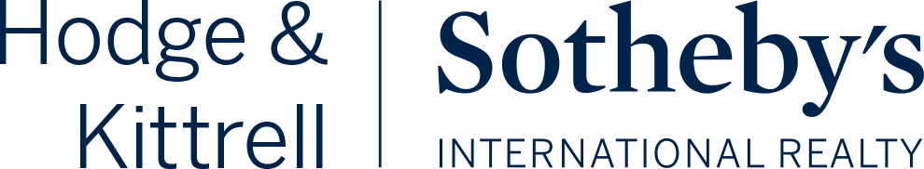

Hailey Hawkins, Ayden Law, Meah Osborne, Taylor Randolph, and Natalie Yeung

Client: Emily Aldrich Barbour
Team Member Contact Info: Taylor Randolph
randolphtaylor35@gmail.com

INTRODUCTION
This public relations campaign was created for our COM 476 (002) course for upper-level students in the Department of Communication’s Public Relations Concentration at North Carolina State University.
Our team worked directly with our client, Emily Aldrich Barbour, a real estate professional with Hodge & Kittrell Sotheby’s International Realty, to prepare a realistic, tangible, and engaging campaign that reflects and upholds their businesses’ core values as well as demonstrates Emily’s unique personal brand.
We gained real-world experience in the growing field of public relations during our development of this strategic plan by applying our PR knowledge, creativity, and tenacity to this project, and it’s been extremely rewarding to see our ideas come to fruition.

TABLE OF CONTENTS
INTRODUCTION 2
TABLE OF CONTENTS 3
OVERVIEW 5
CLIENT BRIEF & CAMPAIGN PROPOSAL 5
SWOT ANALYSIS 5
CLIENT BACKGROUND 5
SWOT GRID 6
SWOT EXPLANATION 6
Internal Analysis: Strengths 6
Political 6
Social 7
Economic 7
Technological 7
Internal Analysis: Weaknesses 8
Political 8
Social 8
Economic 9
Technological 9
External Analysis: Threats 10
Political 10
Social 11
Economic 12
Technological 12
External Analysis: Opportunities 13
Political 13
Social 13
Economic 14
Technological 14
SITUATIONAL ANALYSIS 15
PROBLEM STATEMENT 15
CLIENT MISSION 15
EXISTING STRATEGIES & ACTIVITIES 15
RESEARCH & CAMPAIGNS FROM OTHER ORGANIZATIONS 17
STAKEHOLDERS & AUDIENCE/PUBLICS 18
PRIMARY RESEARCH ON TARGET AUDIENCE 20
ISSUES AFFECTING THE PROBLEM 22
HELPFUL ORGANIZATIONS OR PUBLICS 25
CONCLUDING THOUGHTS 26
GOALS & OBJECTIVES 27
GOAL 27
OBJECTIVE 27
EXECUTION 27
STRATEGIES 27
TACTICS 27
MEASURABLE RESULTS 28
RECOMMENDATIONS AND CONCLUSIONS 29
Immediate Opportunities: 29
Mid-term Opportunities: 30
Long-term Opportunities: 30
REFERENCES 32
APPENDIX 38
Appendix A: HKSIR Target Audience Survey Results 38
Appendix B: Emily in Raleigh Content Calendar 41
Appendix C: Emily in Raleigh Instagram Posts and Captions 45
Instagram Mock Posts 46
Instagram Captions 46
Appendix D: Emily’s Online Presence Content Analysis & Tips 48
Appendix F: PR Campaign Budget 51
Appendix G: PR Campaign Plan Presentations 52

OVERVIEW

CLIENT BRIEF & CAMPAIGN PROPOSAL
Our client is Emily Aldrich Barbour, a real estate agent of the Triangle Area for Hodge & Kittrell Sotheby’s International Realty. Emily is motivated to have a PR campaign plan to get a younger generation’s perspective on her communication practices and to appeal to younger generations, both of which will help her establish her business’ longevity. Our proposed campaign consists of research and deliverables on Millennial and Gen Z client bases.

SWOT ANALYSIS

CLIENT BACKGROUND
Our client contact, Emily Aldrich Barbour, is fun, carefree, approachable, and values class and style. She is an NC State University alum and has served on the Board of the College of Humanities and Social Sciences for 12 years with strong ties to the community. She has been working in real estate for seven years, has been with her company for all seven years, and is in the top 25 agents in the office. Hodge & Kittrell Sotheby’s International Realty is a subsidiary of Sotheby’s International Realty. It was founded about 10 years ago and has locations in Chapel Hill, Raleigh, and one coming soon to Apex.
For this campaign, Emily wants to establish herself as the go-to real estate agent in Raleigh and expand into Millennial and Gen Z client bases. Our scope of work includes creating consistency in her online presence through branding, ideating about her social media strategy, and conducting research on Millennial and Gen Z needs.

SWOT GRID
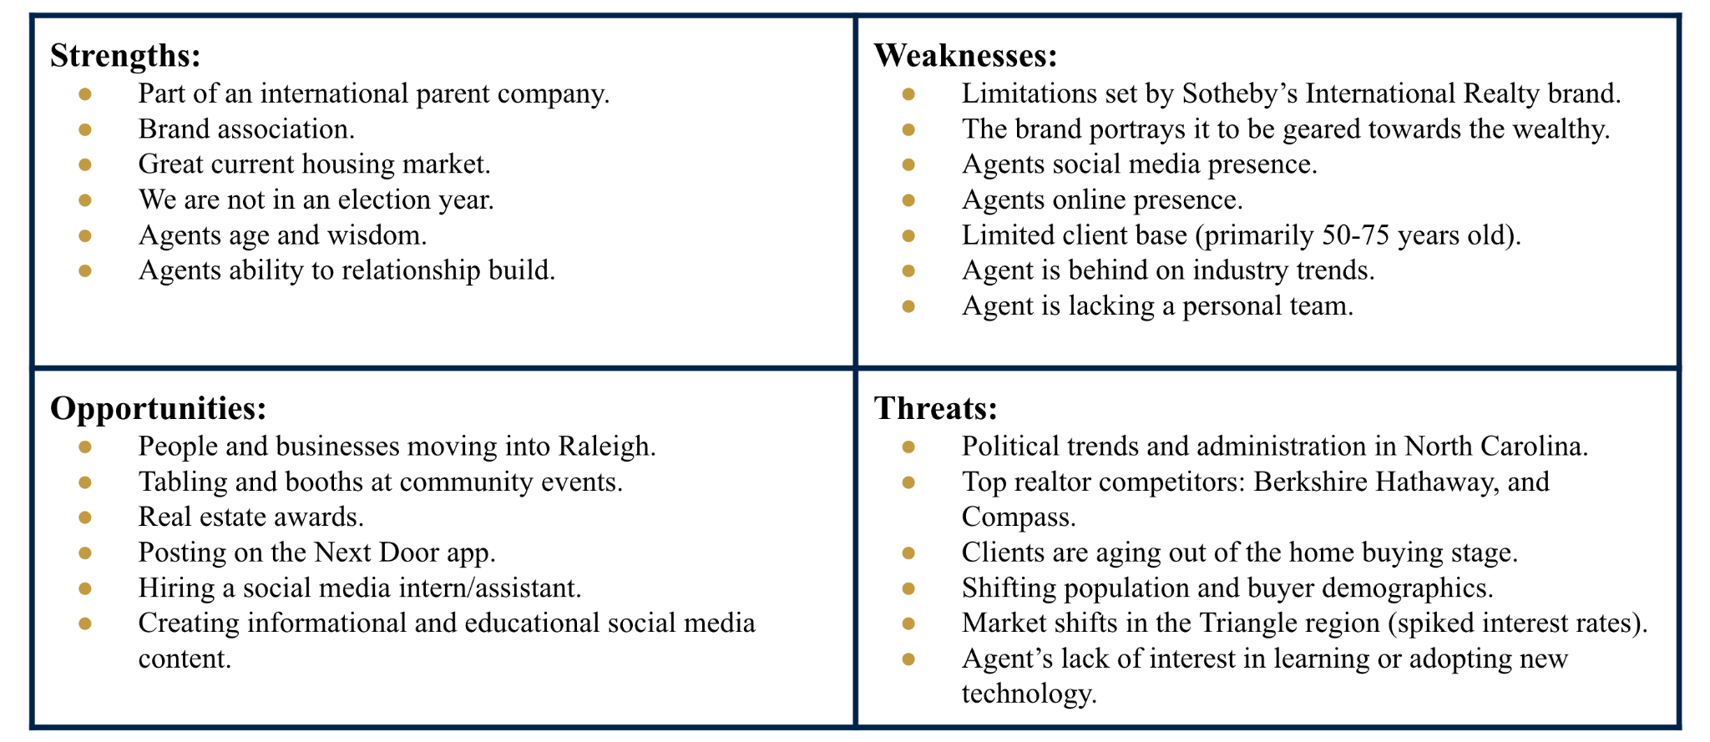

SWOT EXPLANATION

Internal Analysis: Strengths

Political
A significant political strength for Hodge & Kittrell Sotheby’s International Realty is its affiliation with an international parent company. This often indicates influence, a diversified risk profile, and a broad network of contacts (Yoffie, 1988). Such a company is likely used to navigating international regulations and political climates. Being a part of an esteemed brand can also provide global reach and offer leverage in political discussions, as well as in local real estate regulations and development opportunities (Yoffie, 1988).
Election years can bring uncertainty due to policy changes, priority shifts, and disruptions. A non-election year can offer more stability, allowing businesses to operate more efficiently and with greater predictability (Barbour, 2023).

Social
Given her age and wisdom, from a social perspective, real estate professional Emily Aldrich Barbour embodies characteristics that make her brand successful. Typically accompanied by age and wisdom, Emily possesses long-standing traditions and a deep understanding of her customer base, as well as her ability to foster trust and credibility among her clients.
Emily prioritizes relationship building and boasts a high customer retention rate, with over 1,700 customer connections. This enables Emily to better understand and cater to the needs of her audience, promoting strong loyalty and advocacy for customers.

Economic
With the advantage of location, Hodge & Kittrell Sotheby’s International Realty and Emily are housed in one of the fastest-growing areas in the U.S. (Frey, 2022). The vast opportunities for sales, rentals, and property management are endless. Not to mention the thriving current market after the recent real estate slowdown. Customers are becoming more receptive to the idea of buying or selling property, promoting healthy revenue and potential for growth (Siegel, 2023).
Emily also benefits from her association with the prestigious brand Hodge & Kittrell Sotheby’s International Realty. The brand is synonymous with luxury and exclusivity, suggesting premium pricing, attracting high net-worth customers, and ensuring higher commissions.

Technological
Emily has the unique advantage of leveraging Hodge & Kittrell Sotheby’s International Realty affiliation to ensure she has access to a wide variety of cutting-edge technology, tools, and platforms used in the global real estate market (Barbour, 2023). Utilizing these resources allows for efficient operations and enhanced client service for this digital age. Moreover, having access to technological expertise in this field is a significant strength for someone of Emily’s age and would be crucial for staying ahead in the rapidly evolving tech world.

Internal Analysis: Weaknesses

Political
A political weakness for Emily is her reliance on Hodge & Kittrell Sotheby’s International Realty as a brand. Since she works under such a notorious parent company, it leaves small gaps for her own ideas to shine through due to there being a strict set of rules and limitations set out by the brand. These rules are laid out in the brand’s ‘Identity Standards Manual,’ which lays out the ways in which Emily is allowed to showcase the brand to preserve their reputation. This manual includes rules such as how to use the brand name in text, which fonts are permitted, which colors are allowed in marketing, etc. She is also limited by how and where she can market herself as a real estate agent because she has to receive approval from the company for all marketing.

Social
Emily faces a social weakness with her lack of social media presence. While she does have an Instagram account, it lacks direction towards her business. TINT, a marketing platform, recently conducted a study on how social media is replacing Google in younger generations. According to their study, over 75% of consumers have used social media to search for new products and brands (Gutierrez, 2023). This limits her as a realtor because her business can be difficult to find if you don’t know exactly who to look for.
Similarly to her lack of social media presence, she lacks an online presence as well. Her Google business profile offers a link to a website that no longer exists, which could deter potential clients. Currently, only on the Hodge & Kittrell Sotheby’s International Realty website can you find information about her as a realtor. This limits her because only people already interested in working with HKSIR would be able to find her.
Emily faces a social weakness due to her lack of assistance. She currently operates on her own, under her parent company. However, this means that the only marketing assistance she can reach is through the two marketers in her local branch. This limits the amount of content she can produce and the quality of content she can produce since she does not have someone well-versed in PR/marketing to aid her in creating campaigns and media content.

Economic
Hodge & Kittrell Sotheby’s International Realty faces an economic challenge in that their brand image of “luxury” realty can push potential clientele away. While Hodge & Kittrell Sotheby’s does primarily work with luxury homes, it is not their only focus. However, potential clients see the homes listed on their websites and media and become discouraged feeling like they cannot afford to work with the company.

Technological
A technological weakness for Emily is her lack of technological use to obtain clients. Emily shared that the majority of her client base is within her own age range, 50-75 years old. This is because Emily obtains the majority of her clients through word of mouth and already existing connections. This lack of technological use is limiting her in expanding her client base and ultimately will cause her client base to deplete, as senior people are beginning to downsize and settle into their final homes.
Emily faces another technological weakness by being behind on industry trends. With the rise of video content in the form of TikToks and Reels, realtors are beginning to optimize these platforms to showcase their listings, offer realty advice, and overall become more personable to potential clients. In fact, Josh Peters, founding partner at Retsy, claims he sold over $20 million in real estate to clients who found him on Instagram in 2021 (Elliot, 2022). Because of her lack of tech awareness, Emily is unable to participate in these trends, ultimately missing out on younger potential clients.

External Analysis: Threats

Political
Hodge & Kittrell Sotheby’s International Realty is potentially threatened by political trends in North Carolina. The political landscape and economic policies go hand-in-hand as government incentives can affect consumer choices. As the Federal Government raises interest rates, HKSIR is confronted with a potential financial burden that they must pay careful attention to. With rising interest rates, it also means that fewer prospective clients can access the marketplace to purchase property and significantly fewer homes are being put on the market.
The current political climate, such as an election year, can heavily influence homebuyer behavior as presidential races can generate uncertainty in the housing market (Williams, 2020). If you have an administration that creates consumer confidence then they will be more open to spending on big-ticket items like luxury homes. Whereas an administration that creates instability for businesses can also create potential waves of layoffs thus influencing prospective home buyers. According to the Wall Street Journal, the fear of job losses is changing how consumers buy homes making employment contingencies more appealing‌ (Dagher, 2023).

Social
Hodge & Kittrell Sotheby’s International Realty is directly threatened by its top realtor competitors: Berkshire Hathaway, and Compass. While agent, Emily Aldrich Barbour is currently threatened by her limited customer base. Identifying and tracking their industry competitors as well as the channels they use is necessary to ensure that their business is more specialized and comprehensive. HKSIR must learn to target specific audiences and adapt to be niche players in an intensive field. Emily struggles to create a universal and consistent message that immediately builds trust. She also relies on the word-of-mouth method to gain clients.
HKSIR is in the business of high-end real estate and Emily is selling luxury homes which greatly restricts their clientele as many younger generations cannot afford this market. As a repercussion, her clients are aging out since the age bracket that she is appealing to is either downsizing or moving into retirement communities. Emily should work to develop connections with a more diverse customer base to better accommodate both the shifting population and buyer demographics in recent years. It is critical that Emily’s style and presentation appeal to all demographics as Raleigh has continued to become a multicultural area. A census report shows that Raleigh ranks number three among the fastest growing major metro areas between the years 1990-2020 and that we are seeing a “diversity explosion” in the nation’s major metro areas (Frey, 2022).

Economic
Hodge & Kittrell Sotheby’s International Realty is economically threatened by market shifts in the Triangle region as we are seeing interest rates that have nearly doubled into the high sixes (Tollen, 2023).
Other economic challenges include recessions, inflation, and crises like a pandemic which all can highly impact home values. COVID-19 was an enormous threat as homes couldn’t be shown in-person and customers were frantic and buying homes at high prices during 2020-2022. In fact, ABC11 news reported that Raleigh had some of the fastest turn-around times from home listings to sales in the country despite the pandemic (Kummerer, 2020).
Consequently, Emily’s customers are not first-time home buyers so people are going to be reluctant to get out of a low interest rate and go into a high interest rate in 2023. In addition, the inventory of homes to sell has gone down almost 25% but we are still seeing elevated prices, particularly in Raleigh, including for this August compared to 2022 (Triangle Multiple Listing Service, 2023). Things can change rapidly in this line of business, so realtors like Emily must be prepared and able to pivot with a fluctuating market.

Technological
Real estate professional, Emily Aldrich Barbour is threatened by technological innovations due to her lack of interest in learning or adopting new systems. Her limited online presence and minimal activity on social media sites could be restricting her own growth as a real estate broker. Emily hasn’t utilized online platforms to increase the reach of her personal brand, so she may not be reaching her full potential. For example, she lacks posting client testimonials and developing regular content. Additionally, if keeping up with technology may threaten her future success, Emily could hire an assistant to run these accounts on her behalf.
Emily needs a much more robust approach. In today’s modern society, it’s likely that billboards, print advertisements, and other forms of marketing are not as effective as online communities ‌(Council, 2018).
The customers she is likely targeting are successful, busy people who want the ease of doing business via technological platforms. Therefore, Emily must be readily available in using these tools and apps as people often do not want to go out looking for a realtor agent.

External Analysis: Opportunities

Political
Emily could leverage her membership in the National Association of Realtors and the Hodge & Kittrell Sotheby's International Realty realtor network to convert relationships into business. She also can stay informed on legislation, regulations, and policy regarding the real estate industry to keep her practices up-to-date. There is also the opportunity to tailor her services to her clients based on their public voter registration data.

Social
Local, regional and industry-wide recognition can help boost Emily’s reputation and visibility as a top-notch realtor in the Raleigh area. Given her desire to promote herself to other realtors in the Hodge & Kittrell Sotheby's International Realty network so they would refer her to any clients who are relocating to Raleigh, it would work in her favor to be nominated for realtor awards. We believe she would be a strong candidate for most of them and her name would be shared throughout the realtor circles and beyond if she won. Additionally, Emily could take advantage of local community events to table or have a booth to share information about her services. She will increase her accessibility by being in-person and approachable, as well as get the chance to directly talk with her target audience.

Economic
There are many economic opportunities for Emily given her location and industry. Raleigh is consistently growing as a city with more and more businesses moving into the Triangle area. The UNC Kenan-Flagler Business School’s 2022 report, titled the American Growth Project, named the Raleigh-Durham area as fourth of the top 10 fastest growing cities in 2022. The Research Triangle (RTP) was highlighted as a hub for biotech companies and a desirable location for new tech campuses. RTP’s current portfolio includes Cisco, Epic Games, IBM and Red Hat, with Apple establishing its first east coast campus in Raleigh soon (Kenan Institute of Private Enterprise, 2022). Data from a possible competitor of HKSIR found that Raleigh, NC was seventh of the top 10 cities people are dreaming of moving to (Snow, 2023). With these new company campuses, there is a constant stream of employees and job seekers moving in who are looking for houses and realtors to help them find their new home. According to Wake County’s Growth and Population Trends for 2020, “The county grows by approximately 62 people per day, and added 225,000 people over the last decade” (Wake County, 2022).

Technological
Emily recognizes the online opportunities available to her and is looking for our help to understand how she should tackle them. She is motivated to start producing video content for Instagram or TikTok to both inform people about her services and persuade younger audiences to look to her if they need to buy or sell their home. Emily also has online platforms she can expand to that are already specialized toward homeowners, including Nextdoor and Ring. Hiring a social media intern or assistant can also help her bring in more business from younger populations.

SITUATIONAL ANALYSIS

PROBLEM STATEMENT
Emily Barbour is seeing her current client base of 50 to 75-year-old homebuyers age out of needing her services as they are looking to downsize or move to senior living facilities. She needs to expand to millennial and Gen Z clients in the next five years to ensure she has stable and repeat business for the foreseeable future.

CLIENT MISSION
Emily’s mission is to deliver extraordinary customer service with a trained eye for quality home construction, design, and remodeling.

EXISTING STRATEGIES & ACTIVITIES
Currently, Emily has active social media accounts on Facebook, Instagram, and LinkedIn, as well as a personal website page on www.hodgekittrellsir.com and www.sothebysrealty.com. Other existing strategies and activities that Emily has are features in the NC State University Alumni Magazine and the Sir Walter Raleigh Magazine, brand standards written by Sotheby’s International Realty, and a marketing plan for 2023 (Barbour, 2023). To gather more information on our client’s existing strategies and activities our group decided it would be best to conduct a social media content analysis of Emily’s Facebook and Instagram. For this analysis, we looked at her 10 most recent posts on Facebook and her 20 most recent posts on Instagram. Currently, she has 242 followers on Facebook and 331 followers on Instagram. We created a Google Form to help us organize our findings for each post. Our team wanted to get a feel for Emily’s strengths and weaknesses on social media to help her make improvements to her platforms so that she can expand her client base and gain popularity and familiarity as a real estate agent.
For each of the social media posts, we choose to analyze the content, captions, likes and reactions, and comments. The form contained questions about if the post was a video or image, how many photos or videos, what was present in the photos or videos, what the caption contained, how many likes, how many comments, information about the people commenting, and if hashtags were used.
What our group gathered from the results is that Emily is not active on social media often nor is she consistent with her posts. Her Instagram contains a mix of personal posts and real estate-related posts, but her Facebook is primarily used for real estate content. She has only posted three videos between the two platforms and her most recent video post has 101+ views. Emily’s comments are primarily from women and people who are middle-aged to older adults.
The results that we gathered from the social media content analysis will be used to support our reasoning behind our problem statement. Before Emily can market to Gen Z and Millennials, she will need to grow her social media presence, become consistent with her message, and appeal to her target audience.

RESEARCH & CAMPAIGNS FROM OTHER ORGANIZATIONS
In the ever-evolving landscape of the real estate market, it is crucial to comprehend the subtle differences between generations, particularly as Millennials and Gen Z begin to make their mark. The National Association of REALTORS reports that although Gen Z represents a modest 2% of buyers and sellers, their consistent interest in homeownership suggests untapped potential for market expansion and future growth. Growing up amidst an era defined by technological advancements and instant communication, millennials expect immediate results and seamless digital experiences. Their early economic success, juxtaposed with setbacks such as the 2008 financial crisis and the COVID-19 pandemic, has profoundly shaped their financial perspectives and risk tolerance (2022 Home Buyers and Sellers Generational Trends Report, 2022).
Digging deeper into these generational characteristics, research from Stanford University reveals that diversity, collaboration, and flexibility are values prioritized by Gen Z. They strive to strike a balance between pragmatism and activism, especially on issues like climate change. In contrast, Pure Wow highlights how millennials prioritize quality time with family and mental well-being over traditional measures of success. Moreover, AZ Big Media and The Plan Collection emphasize their affinity for smart living spaces designed with environmental sustainability in mind, further accentuating their unique home preferences.
An emerging trend in homeownership habits, as reported by CNBC, is the perception of property ownership as a sign of success—shared by 65% of millennials and 59% of Gen Z. Geographically. there is a clear inclination towards inland cities, likely driven by job opportunities and affordability, as reported by The New York Times.
For real estate agents, these insights require an adaptive approach. The growing trend toward remote and flexible working, as captured by Bankrate, reflects millennials’ readiness to relocate in search of a better home environment. Additionally, the digital trust shown by millennials, with nearly a quarter of them willing to buy property online without conducting a physical inspection, as noted by Forbes, points to the importance of strong online real estate marketing ownership.
Still, obstacles remain. The National Association of REALTORS points out the lingering shadow of student loan debts, with about 29% of those in debt admitting it influences their home-buying decisions. For agents to maintain their edge and stay relevant, it's essential to weave tech-savvy approaches with an understanding of these socio-economic factors, reflecting the evolving focus on well-being, environmental consciousness, and digital engagement in their client communications and property marketing strategies.

STAKEHOLDERS & AUDIENCE/PUBLICS
Emily’s stakeholders would be her employees, the Hodge and Kittrell company executives, and herself. These are the people who will be directly impacted if Emily does not expand her client base as they continue to age out. Emily’s audience is homebuyers of all ages, with Boomers and Gen X being probable, Millennials being possible, and Gen Z being unlikely. Boomers and Gen X are Emily’s current customers, making them the most probable age group. Millennials are rising to the age where they can afford to purchase homes, this makes them a possible audience but due to the price of the homes Emily is known for selling, they are not a probable audience. Gen Z is an unlikely audience because their current age (11-26) makes them unlikely to purchase a home at all (Yale, 2023). This is further reflected in Emily’s current relationship with these audiences. Emily has a good relationship with Boomers and Gen X and little to no relationship with Millennials and Gen Z.
The self-interest of these audiences would be gaining assistance from a professional real estate agent and acquiring a new home. In a survey our team conducted, we found that the majority of responses admitted to knowing very little about the home-buying process. A real estate agent is helpful in this case because they have the knowledge and experience of buying and selling homes that these audiences are looking for. Emily’s audience opinion leaders and influencers would be young homeowners and online influencers who showcase their homes. Older audiences, such as Boomers and Gen X have the life experience of knowing what qualities they want in their homes —south-facing windows, stainless steel appliances, etc. However, for younger audiences like Millenials and especially Gen Z, their knowledge of what features they want in their homes comes from people their age or online influencers sharing their home tours or amenities via the media they consume (Writer, 2022).
There are many considerations that Emily’s audience faces. A financial cost is that the majority of Gen Z or Millennials cannot afford to buy homes in the current housing economy (Rodriguez, 2022). An emotional cost comes in the form of the excess stress caused by house hunting (Mastroeni, 2019). This stress is so well known among people who have purchased homes that Forbes created a how-to for homebuyers to minimize their stress. A potential societal cost is younger audiences moving away from their usual crowds, away from their hometown or college town. A temporary cost to buying a home would be the actual hiring of a real estate agent and the varying listing fees (Ceizyk, 2023). Lending Tree discusses the financial rewards for homebuyers, some of which would be buying a house allowing you to build credit and equity and gain financial control over things such as monthly payments. An emotional reward to buying a home would be the comfort of privacy in your own home and the freedom of owning your own space that isn’t the property of someone else (Into the Pixel, 2023). The Minnesota Homeownership Center shares societal benefits of homeownership, key ones being the stability that buying brings to a neighborhood and the increased tax dollars your new community will gain (Minnesota Homeownership Center, 2022).

PRIMARY RESEARCH ON TARGET AUDIENCE
Our team conducted a survey on the target audience of Gen Z and Millennials who live in the Triangle Area. A survey was chosen over interviews or focus groups to gather larger quantitative and qualitative data about the age groups Emily wanted to learn about. Specifically, Emily wanted to understand what amenities and factors Gen Z and Millennials consider when picking a home and how they would want to receive information about home buying. Our team wanted to understand Gen Z and Millennials’ attitudes toward home buying to help tailor Emily’s messaging. Bringing both goals together, we used Google Forms to create a comprehensive online survey to ask questions about the current housing situation, desired amenities in a house, homebuying likelihood, understanding of homebuying, platforms used to find homes, platforms used to learn about home buying, attitudes towards realtors, and awareness of popular real estate companies for both publics.
In order to ensure we only gathered data from Gen Z and Millennials who lived in Emily’s jurisdiction, we asked all respondents the preliminary question “Do you live in the Triangle Area?” Those who answered yes continued with the rest of the survey while those who answered no were thanked for their time. From there, the remaining respondents entered the first section of questions where they were asked demographic questions about their gender, race and ethnicity, employment status, and education level. The last question asked respondents to pick the range of years that includes their birth year, allowing them to be divided into Gen Z (1997-2012) and Millennials (1981-1996). Both groups were asked the same 15 questions in the next section but could be more easily compared by their age group.
The results of the survey show the following insights into Millennial perspectives, Gen Z perspectives, and their comparison. When it comes to amenities in a home, Millennials most commonly mention the kitchen, bathrooms, and bedrooms as important. Gen Z most commonly mentioned modern appliances (with a frequent specification of in-unit washer and dryer), a yard, and location as important. Millennials’ ideal price range is $500,000-$600,000 while Gen Z’s is $200,000 - $300,000, with $300,000 - $400,000 close behind. Millennials answered either extremely familiar or moderately familiar with steps to buying a home and mortgages while Gen Z most frequently answered not familiar or slightly familiar. Both Millennials and Gen Z primarily use Zillow and real estate agents when looking for a home, and Gen Z also mentioned Realtor.com and open houses. Both publics also prefer to use listing websites and real estate agency websites for information on home buying. Interestingly, Millennials were the ones who listed Instagram for information on home buying while Gen Z listed Facebook. While the majority of both groups know a real estate agent, Millennials tend to have more negative attitudes towards realtors compared to Gen Z who have overwhelmingly positive attitudes towards realtors. Despite the differences in attitudes, both publics frequently expressed client understanding, listening, and advocacy alongside knowledge as important qualities of realtors. Lastly, millennials were more aware of top real estate agencies in the Triangle Area than Gen Z.
From our preliminary analysis of our primary research, we observed some key differences between the two target audiences of Gen Z and Millennials. Some results were expected due to our secondary research and prior understanding of our publics, and some were surprising to us. A more in-depth analysis will be provided in the final campaign plan.

ISSUES AFFECTING THE PROBLEM
The problem our team is working to solve through our robust campaign is enhancing and expanding Emily’s current and new customer base in a digital age. To do this, we must examine the issues affecting this problem which include interest rates, target market, communication channels, and adopting new technology.
Firstly, Emily needs to consider how fluctuating interest rates will impact her business performance in the present and future. A problem is that Emily needs new clients, but an issue is that the younger generations who are in her target market for larger, luxury houses and family homes may not be able to afford it because of their reluctance to take on the new, high interest rates. According to the Chief Economics Correspondent for NPR News, the average home mortgage interest rate topped seven percent in August 2023, making it the highest it’s been in more than two decades. He stated, “A year ago, rates were just over five percent. That increase means someone borrowing $300,000 on a house can expect to pay about $400 more every month,” (Horsley, 2023). In addition, as noted by a Coldwell Banker survey, 35% of its respondents appeared to be hesitant to purchase a home due to the rising interest rates and over 27% of its respondents feared that a potential recession would halt their luxury home purchase decision. The survey stated that the areas of greatest concern for homebuyers in 2023 are stock market fluctuation, inflation, and higher home prices (Pacaso, 2023). This goes to show that fears are arising in the luxury real estate market.
Secondly, Emily needs to consider who is in her ideal target market and how she can expand this market. Another problem is that Emily needs to address the generational gap in her customer base, but an issue is whether she has the tools to expand into this market. Emily must adapt her marketing approach by using effective technological strategies including social media platforms to secure retention but more importantly, grow her business and appeal to younger generations. To best understand this, let’s review the average age of a luxury homebuyer. In fact, CBS News reported that Baby Boomers overtake Millennials as the largest generation of homebuyers as indicated by The National Association of Realtors. NAR data from March 2023 reveals that Boomers, ages 58-76, made up 39% of home buyers in 2022, compared to 28% for millennials. This is a 29% increase from last year, making it the highest percentage of any generation. There’s no doubt that Boomers make up the majority of Emily’s customer base, but with her clients beginning to age out, she needs to find new ways of marketing herself to the growing population of Millennials particularly in the Triangle Area.
Thirdly, Emily needs to consider which communication channels she tends to rely on and which she should embrace to grow the reach of her brand. An additional problem is that Emily relies on word-of-mouth referrals which works, but an issue is that her likely referral base is going to be similarly situated and not in the position to buy a new house. She needs to focus on revamping her avenues and expanding her network to go after the buyers that she is looking for. Since luxury real estate is a highly desirable and competitive market, we must first look at who is in the market for luxury homes. As referenced in an article about luxury real estate market trends for 2023, smaller homes are becoming more popular among luxury homebuyers and in some cases, cheaper. In fact, in 2022, they sold 19% faster than larger ones. This research suggests that affluent buyers may not need the extra square footage due to their busy lifestyles which means that downsizing might become the new normal with increasing home prices (Pacaso, 2023). With downsizing becoming a new threat to luxury real estate, Emily will need to pivot her approach to be more inclusive by highlighting multiple homebuyer trends as this line of business isn’t just a one-size-fits-all methodology.
Lastly, Emily needs to consider adopting new technology to attract digital natives through mobile-friendly websites and keep up in today’s fast-paced, multimedia society. An alternative problem is that people are using technology where you buy/sell and are no longer building a relationship with a realtor thus reducing the agent commission, in order to sell to Millennials, Emily faces the issue of having to compete with newer and more innovative methods of real estate from third parties. Furthermore, apps and websites such as realtor.com, help-u-sell.com, and other flat fee real estate sellers promote how to find what you’re looking for without having to pay high-end real estate commissions. The digital landscape is rapidly changing, which could create potential consequences for Emily. Let’s examine what percentage of homebuyers are using new technology. “According to a NAR 2022 Home Buyers and Sellers Generational Trends Report, 95% of homebuyers of all age groups used the internet during their home search, and just over half found the property they would eventually purchase online” (CoreLogic, 2022). Now knowing that people are less likely to use a realtor agent to buy homes could create some new challenges for Emily. While she is likable for her unique personality, her online presence is slim. Emily has an excellent personal brand that also needs to be communicated through her online brand. To maximize her opportunity to build relations with new clientele and set herself apart from online realty sites, digital advertising should become her new best friend.

HELPFUL ORGANIZATIONS OR PUBLICS
Our team looked externally at the environment and landscape to consider additional resources available to our client. Some helpful organizations to help Emily address this problem are opinion leaders on building wealth (buying a home and establishing equity), other realtors, educational institutions, and local realtor associations. We believe Emily can collaborate with these publics to increase her success with acquiring Gen Z and Millennial clients.
As mentioned earlier, Emily’s audience opinion leaders and influencers are young homeowners and online influencers who showcase their homes. Additionally, they could be online influencers who encourage others to build wealth through buying a home. Emily can take inspiration from the social media content of this public to create her own or reach out to them for a mutually beneficial partnership. Other realtors within the Hodge & Kittrell Sotheby’s International Realty network can share their experiences and advice with Emily. It would be especially beneficial if they had any examples of strategies and tactics they used, as well as an evaluation of their effectiveness, to share with Emily. One of Emily’s co-workers currently runs a realtor TikTok account where she creates home-buying and selling content. This coworker can provide insight and guidance to Emily about maximizing engagement and client conversion for the video content that Emily hopes to create in the future (Barbour, 2023). Educational institutions and local realtor associations could help Emily inform her target audience about the home-buying process through a speaker series or community events.

CONCLUDING THOUGHTS
Through our primary and secondary research regarding the problem, client organization, existing strategies, target audience, stakeholders, relevant issues, and helpful external parties, our team has come to a holistic understanding of the situation and the reason behind the need for a public relations campaign. Our analysis and services as PR practitioners are essential to Emily at this time in order to address the problem statement before it becomes a crisis. Using all of the work compiled above, we will continue to create an informed, relevant, and beneficial campaign plan by the end of the semester to aid Emily’s long-term success.

GOALS & OBJECTIVES

GOAL
Enhance Emily Aldrich Barbour's reputation as the go-to real estate agent in Raleigh and develop a consistent online presence to help her expand into Millennial and Gen Z client bases.

OBJECTIVE
Within the next 12 months, enhance Emily Aldrich Barbour’s online presence by achieving a 30% increase in her social media followers from Millennial and Gen Z client bases.

EXECUTION

STRATEGIES
- Strengthen Emily’s ability to attract Millennial and Gen Z clients by increasing her understanding of the target publics’ behaviors and attitudes
- Establish Emily as the go-to-agent in the Triangle Area by improving her online presence and social media visibility to her target audience

TACTICS
- Create and distribute a Google Form survey to gather research and data on Millennial and Gen Z publics (see Appendix A)
- Develop a content calendar for Instagram and Facebook to set a regular and consistent posting schedule (see Appendix B)
- Write possible Instagram captions for her “Emily in Raleigh” series to show off her expertise and direct followers to use her services (see Appendix C)
- Establish tips and guidelines to help Emily transition her Instagram and Facebook social media accounts to better represent her professional persona based on a content analysis of her current online presence (see Appendix D)

MEASURABLE RESULTS
The success of our execution of the proposed strategies and tactics can be evaluated by analyzing the results in measurable terms. The metrics we believe to be most telling and significant to Emily are as follows:
- Increase average likes on Instagram from the current average of 19.2 likes (ranging from February 2020 to November 2023) to an average of 100 likes on posts starting from the beginning of the campaign.
- An increase in Millennial and Gen Z followers by 30 % from the beginning of the campaign to the end.
- Increase in website traffic as Millennials and Gen Z become more aware of Hodge & Kittrell Sotheby’s.
  - Our HKSIR Target Audience Survey proves the company is not as well known by these publics (see Appendix A)

RECOMMENDATIONS AND CONCLUSIONS
Based on our secondary research, primary research, and proposed PR plan, we have formulated several recommendations to further Emily’s success. Here are some big ideas that we think Emily should consider as we transition from what we have already accomplished to what we are looking forward to, broken down into immediate opportunities to be done in the next three months, mid-term opportunities to be done in the next six months, and long-term opportunities to be done in the next year:

Immediate Opportunities:
- In the next three months, we recommend that Emily take part in celebrating Raleigh’s greatest holiday traditions. Whether it’s attending the Wendell Wonderland lights festival, the Chinese Lantern Festival in Cary, the downtown Raleigh or State Capitol tree lighting celebrations, the grand Christmas parade in the historical downtown Apex, or the Holiday Express at Pullen Park. She should mark her calendar to attend these upcoming events as a prominent figure in her ‘Emily in Raleigh’ campaign. This will help her maintain status and visibility in the Raleigh community and spread holiday cheer among her key publics.
- Looking at what is currently working for Emily in the short term, we know that Baby Boomers and Gen X continue to make up the majority of her customer-base, and so we recommend that she keeps going after them for quicker turnover. These age groups have the cash and equity in their existing homes and because of the current state of the economy, it may take time for younger audiences to tackle the high interest rates.

Mid-term Opportunities:
- In the next six months, Emily can continue a targeted direct mailing approach as it is a great way to attract attention from homeowners and buyers. Door direct mail, neighborhood mailings, and new mover-marketing postcards are tangible, eye-catching visuals that can generate new prospects. This is a good option because it’s more likely to be seen than junk emails. Traditional advertising can reach a wide audience and strengthen her brand awareness for future reference.
- Emily should also expand from email campaigns only. In addition to this, we recommend that she consistently post her ‘Emily in Raleigh’ campaign to Instagram using her diverse photos capturing notable landmarks in Raleigh alongside with the strategic and rich captions our team provided for her. We believe this campaign should be launched from January 2024 – July 2024. This will boost engagement and her online presence as well as promote the city and drive enthusiasm for the campaign!

Long-term Opportunities:
- In the next year, we recommend that Emily attend functions where she knows her desired audience will be. For example, animal rescue events, wine bars, cocktail hours, holiday-themed events, and open houses for new businesses in the Triangle to name a few.
- Emily could also begin doing partnerships to draw in a greater crowd. To showcase her personal side, we recommend that she sponsor nonprofit or charity events. This will get her name out there and increase publicity. Additionally, younger audiences attend many walk-run-biking events to support good causes. For instance, Raleigh has annual charity events such as the Dia de Muertos 5k race, Gobble Til You Wobble 5k/10k, I Have a Dream 5k/10k, the Krispy Crème Challenge dedicated to the NC Children’s Hospital, and Walk for Hope to raise awareness mental illness. These are our suggestions but there are so many to choose from!
- Since the ‘Emily in Raleigh’ campaign is her key deliverable, we recommend that she continue this throughout the rest of the year. Raleigh is known as “The City of Oaks” and as “The Smithsonian of the South,” and residents of Raleigh are proud to live here. As no surprise, it’s voted the best city in North Carolina from the unique arts to the culture to the entertainment, Raleigh has gained the reputation of being a multicultural hub. Offering more than 40 free attractions, Emily can take advantage of these and further develop her ‘Emily in Raleigh’ campaign to add more flair.

REFERENCES
2022 Home Buyers and Sellers Generational Trends Report. (2022). National Association of REALTORS. Retrieved from https://cdn.nar.realtor/sites/default/files/documents/2022-home-buyers-and-sellers-generational-trends-03-23-2022.pdf?_gl=1*113r69a*_gcl_au*MTAyNDYxMDI0Ni4xNjk4MjA2Nzg2.
8 Luxury Real Estate Market Trends for 2023. (2023, August 7). Pacaso. Retrieved from www.pacaso.com/blog/luxury-real-estate-market.
Baby Boomers Overtake Millennials as Largest Generation of Home Buyers. (2023, March 28). National Association of REALTORS®. Retrieved from www.nar.realtor/newsroom/baby-boomers-overtake-millennials-as-largest-generation-of-home-buyers.
Barbour, E. (2023, September 20). COM 476: HKSIR Client Meetings. COM 476 Hodge & Kittrell Sotheby International Realty. Retrieved from https://docs.google.com/document/d/12CCARGBjKNf8gIOn7hkrzUl_p9IqX9YWlHJjEANW218/edit?usp=sharing.
Ceizyk, D. (2023, August 15). 10 Benefits of Owning A Home. LendingTree. Retrieved from https://www.lendingtree.com/home/mortgage/benefits-of-owning-home/#youllbuildhomeequitywitheachmonthlypayment.
Council, F. C. (2018, March 2). Council Post: Does Print Still Have A Place In The Future Of Advertising? 10 Experts Weigh In. Forbes. Retrieved from https://www.forbes.com/sites/forbescommunicationscouncil/2018/03/02/does-print-still-have-a-place-in-the-future-of-advertising-10-experts-weigh-in/?sh=374b345b5fc6.
Dagher, V. (2023, March 27). Fear of Layoffs Is Changing How People Buy Homes. Wall Street Journal. Retrieved from https://www.wsj.com/articles/home-buyers-big-ask-the-deal-is-off-if-i-lose-my-job-d9f30f45.
De White, M. (2022, January 3). What To Know About Gen Z. Stanford News. Stanford University. Retrieved from https://news.stanford.edu/2022/01/03/know-gen-z/.
Elliott, S. (2022, June 6). How Top Agents Are Leveraging Social Media To Sell Homes in 2022. Forbes. Retrieved from https://www.forbes.com/sites/forbes-global-properties/2022/06/02/how-top-agents-are-leveraging-social-media-to-sell-homes-in-2022/?sh=256d2ca08b8c.
The Freedom of Homeownership: Reasons for Owning A House. (2023, June 7). Into the Pixel. Retrieved from https://intothepixel.com/freedom-of-homeownership-reasons-for-owning-a-house/.
Frey, W. (2022, April 21). A 2020 Census Portrait of America’s Largest Metro Areas: Population Growth, Diversity, Segregation, and Youth. Brooking Mountain West. 1-31. Retrieved from https://www.brookings.edu/wp-content/uploads/2022/05/A-2020-Census-Portrait-of-America_s-Largest-Metro-Areas_-Populati.pdf.
Gutierrez, E. (2023, September 15). Social Media Is Now A Search Engine. TINT Blog. Retrieved from https://www.tintup.com/blog/social-media-is-now-a-search-engine/.
Here’s How Millennials Are Creating Trends In Home-buying Market. (2021, July 19). AZ Big Media; AZ Business Magazine. Retrieved from https://azbigmedia.com/real-estate/residential-real-estate/heres-how-millennials-are-creating-trends-in-home-buying-market/.
Horsley, S. (2023, August 22). The Average Home Mortgage Interest Rate Now Tops 7%, the Highest in 20+ Years. NPR. Retrieved from www.npr.org/2023/08/22/1195291841/the-average-home-mortgage-interest-rate-now-tops-7-the-highest-in-20-years.
Huddleston, T. (2022, June 12). Millennials and Gen Zers Want To Buy Homes—But They Can’t Afford It. CNBC. Retrieved from https://www.cnbc.com/2022/06/12/millennials-and-gen-zers-want-to-buy-homes-but-they-cant-afford-it.html.
The Impact of Student Loan Debt. (n.d.). National Association of REALTORS. Retrieved from https://cdn.nar.realtor/sites/default/files/documents/2021-the-impact-of-student-loan-debt-full-report-09-14-2021.pdf?_gl=1*jme691*_gcl_au*MTAyNDYxMDI0Ni4xNjk4MjA2Nzg2.
Kenan Institute of Private Enterprise. (2022, October). October Report: 2022’s Fastest-Growing U.S. Cities, Ranked. The American Growth Project. Retrieved from https://kenaninstitute.unc.edu/wp-content/uploads/2022/10/american-growth-project-10172022r.pdf
Kummerer, S. (2020, August 6). Raleigh Housing Market Skyrockets Despite The COVID-19 Pandemic. ABC11 Raleigh-Durham. Retrieved from https://abc11.com/raleigh-homes-for-sale-houses-rent/6356063/.
Martin, E. J. (n.d.). ‘Unmortgaged Millennials’: Understanding Gen Y Buyers. Bankrate. Retrieved from https://www.bankrate.com/real-estate/unmortgaged-millennials-study/.
Mastroeni, T. (2019, June 24). 4 Ways To Keep From Getting Overwhelmed When House Hunting. Forbes. Retrieved from https://www.forbes.com/sites/taramastroeni/2019/06/24/these-4-factors-will-help-keep-you-from-getting-overwhelmed-when-you-first-start-house-hunting/.
Meister, S. (2022, June 2). Millennials Are Embracing An Old-Fashioned Home-Buying Trend. PureWow. Retrieved from https://www.purewow.com/home/millennial-silent-generation-home-trend
Minnesota Homeownership Center. (2022, September 21). Social Benefits of Homeownership And Stable Housing. Retrieved from https://www.hocmn.org/blog-post/social-benefits-of-homeownership-and-stable-housing/.
Moore, M. (2022, May 25). The Power To Drive Change: How Millennials Are Affecting The Housing Market. Forbes. Retrieved from https://www.forbes.com/sites/forbesbusinesscouncil/2022/05/25/the-power-to-drive-change-how-millennials-are-affecting-the-housing-market/?sh=4ef531ef716c.
Rodriguez, J. (2022, November 23). Sorry, Millennials, You’re Never Getting A Good Home. Business Insider. Retrieved from https://www.businessinsider.com/millennials-house-home-real-estate-mortgage-rates-rent-debt-boomers-2022-9.
Schmidt, G. (n.d.). Gen Zers Are Buying Homes. Here’s Where They’re Looking. The New York Times; The New York Times. Retrieved from https://www.nytimes.com/2022/05/26/realestate/generation-z-home-buying.html.
Siegel, R. (2023, July 17). The Housing Market Recession Is Already Ending. The Washington Post. Retrieved from www.washingtonpost.com/business/2023/07/17/housing-market-recession/.
Snow, A. (2023, September 26). Are Americans Looking to Move? New Data from the Coldwell Banker Move Meter Reveals Shocking Search Destinations. Coldwell Banker Blue Matter. Retrieved from https://blog.coldwellbanker.com/2023-move-meter-searches/.
Triangle Multiple Listing Service. (2023, September 10). Local Market Update – August 2023. Showing Time. Retrieved from https://www.trianglemls.com/clientuploads/TMLS/Market%20Trends/Local%20Market%20Updates/2023/August/Entire-Triangle-Region.pdf.
Tollen, L. (2023, August 21). Expert Insights for the Rest of the Year in Housing. My NC Homes. Retrieved from https://www.mynchomes.com/blog/expert-insights-for-the-rest-of-the-year-in-housing.html.
Wake County. (2022, February 11) Growth and Population Trends. Census & Demographics. Retrieved from https://www.wake.gov/departments-government/planning-development-inspections/planning/census-demographics/growth-and-population-trends.
What Are Millennials Looking for When Purchasing a Home? (n.d.). The Plan Collection. Retrieved from https://www.theplancollection.com/blog/what-are-millennials-looking-for-when-purchasing-a-home.
Williams, D. (2020, February 16). Here Is What A Presidential Election Means For Home Sales And Prices. Forbes. Retrieved from https://www.forbes.com/sites/dimawilliams/2020/02/16/here-is-what-a-presidential-election-means-for-home-sales-and-prices/?sh=a45566225fce
Writer, G. (2022, November 4). How Influencer Culture is Impacting the Real Estate Industry in Powerful Ways - [Talking Influence]. Hello Partner. Retrieved from https://hellopartner.com/2022/03/25/how-influencer-culture-is- impacting -the-real -estate-industry-in-powerful-ways/.
Yale, A. J. (2023, January 4). Millennial Homebuyers: What The 2023 Housing Market Looks Like for Gen Y And Gen Z. US News & World Report. Retrieved from https://realestate.usnews.com/real-estate/articles/millennial-homebuyers-what-the-housing-market-looks-like-for-gen-y-and-gen-z.
Yoffie, D. B. (1988, May 1). How an Industry Builds Political Advantage. Harvard Business Review. Retrieved from https://hbr.org/1988/05/how-an-industry-builds-political-advantage.

APPENDIX

Appendix A: HKSIR Target Audience Survey Results
Conducting a survey on home buyer behaviors for Millennials and Gen Z is crucial as these generations wield significant influence in the real estate market. Shaped by unique economic and cultural factors, understanding their preferences in home buying dynamics and decision-making is essential. This survey enables real estate professionals like Emily to tailor strategies and offerings, ensuring they stay attuned to the distinct needs of Millennials and Gen Z in the rapidly changing real estate landscape.
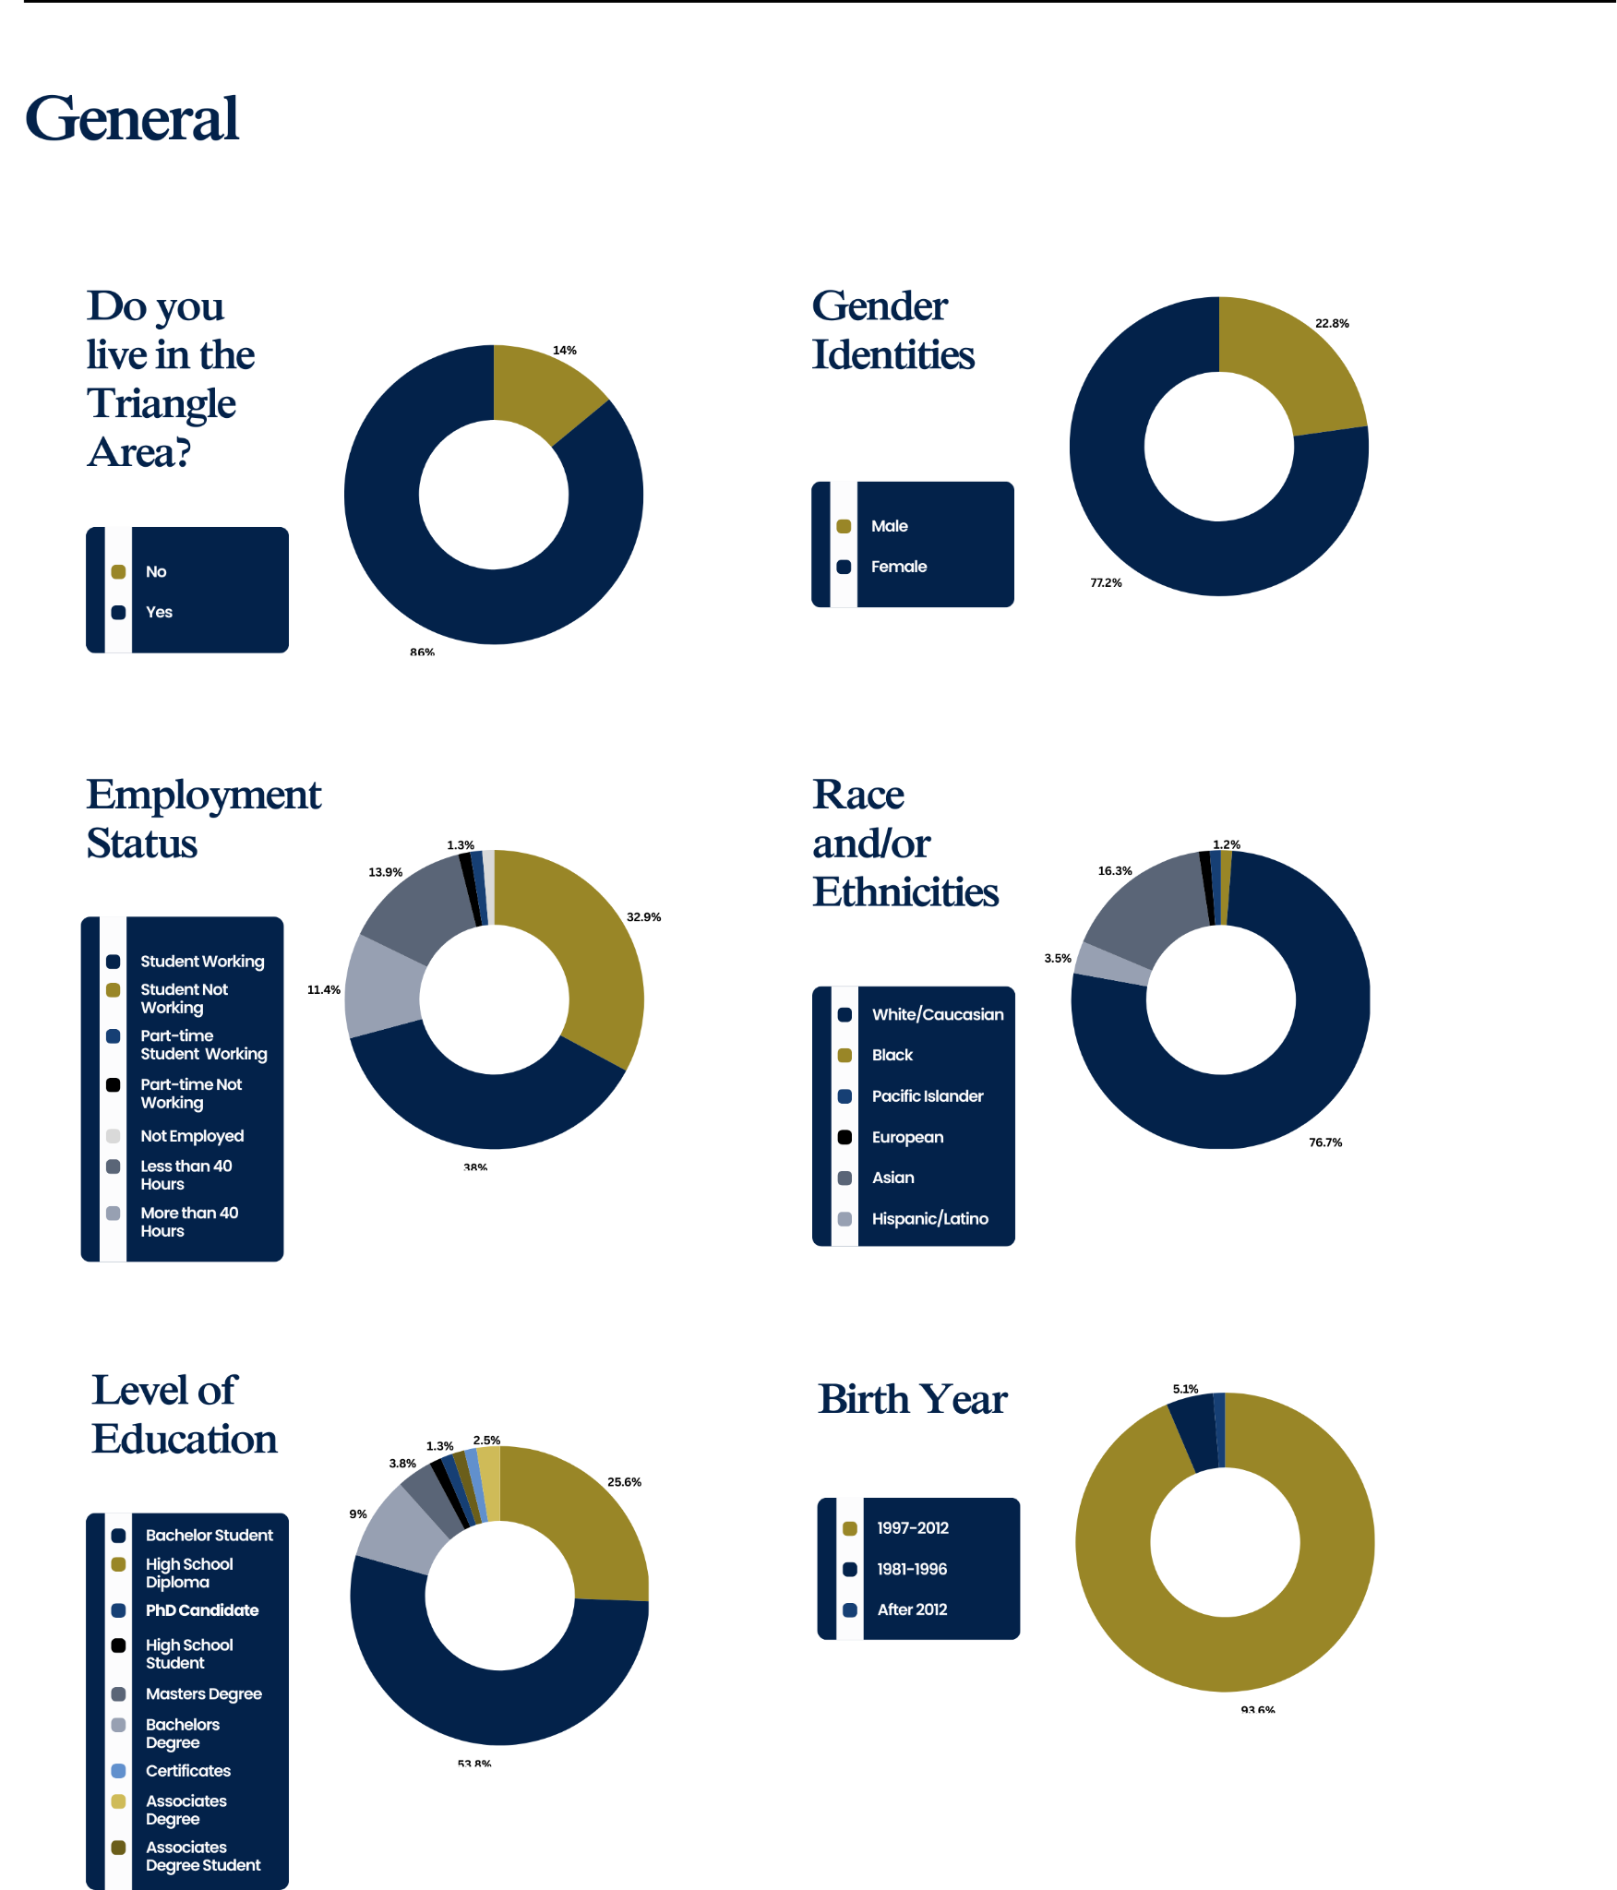

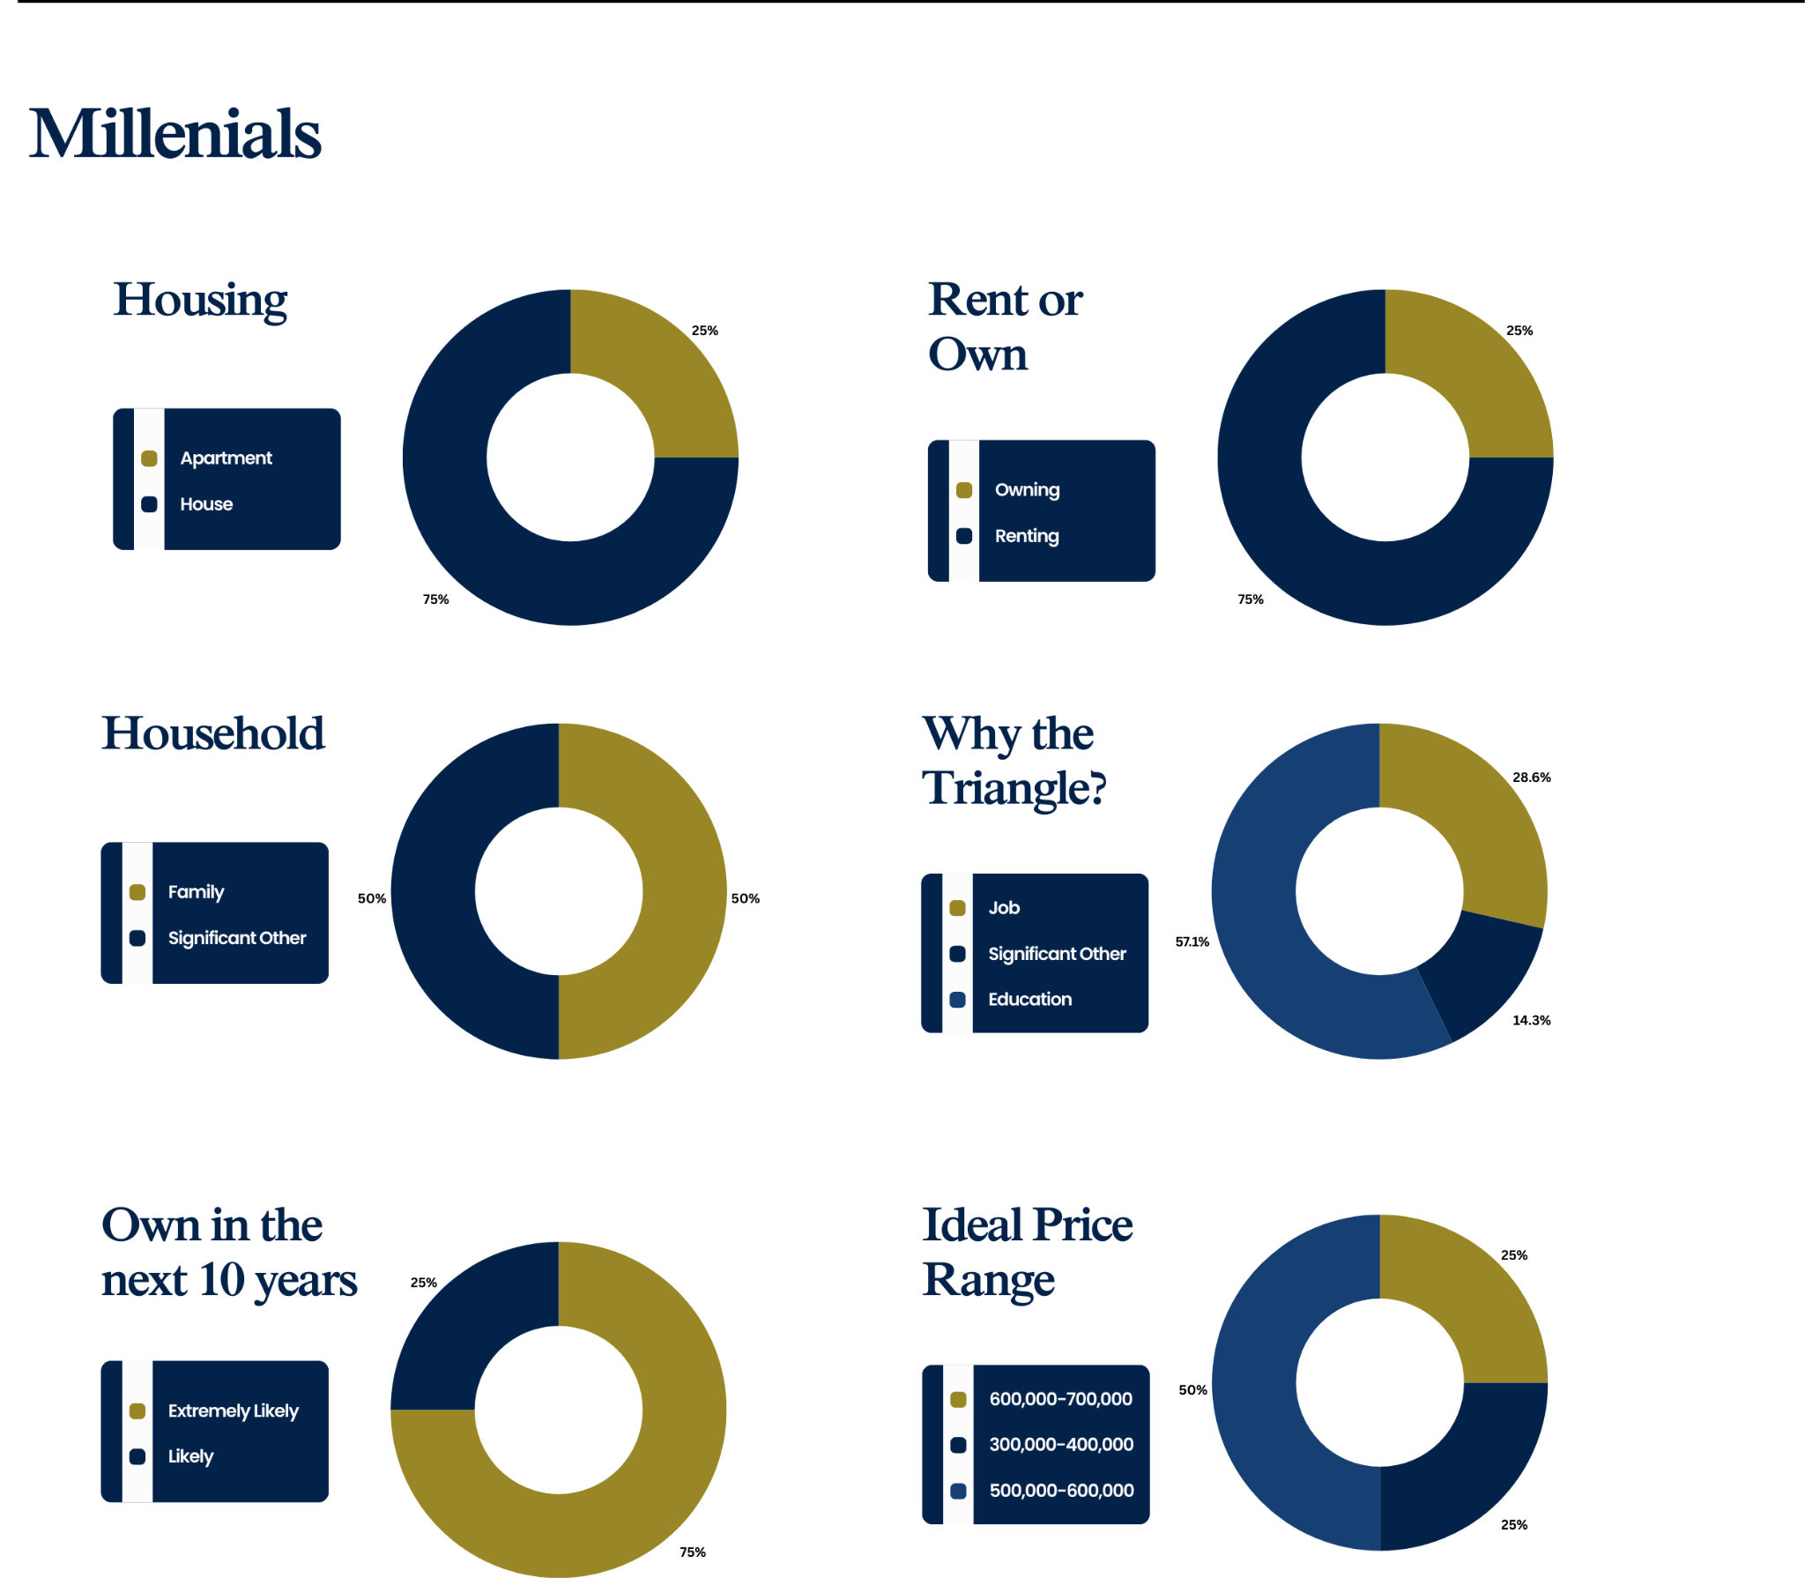
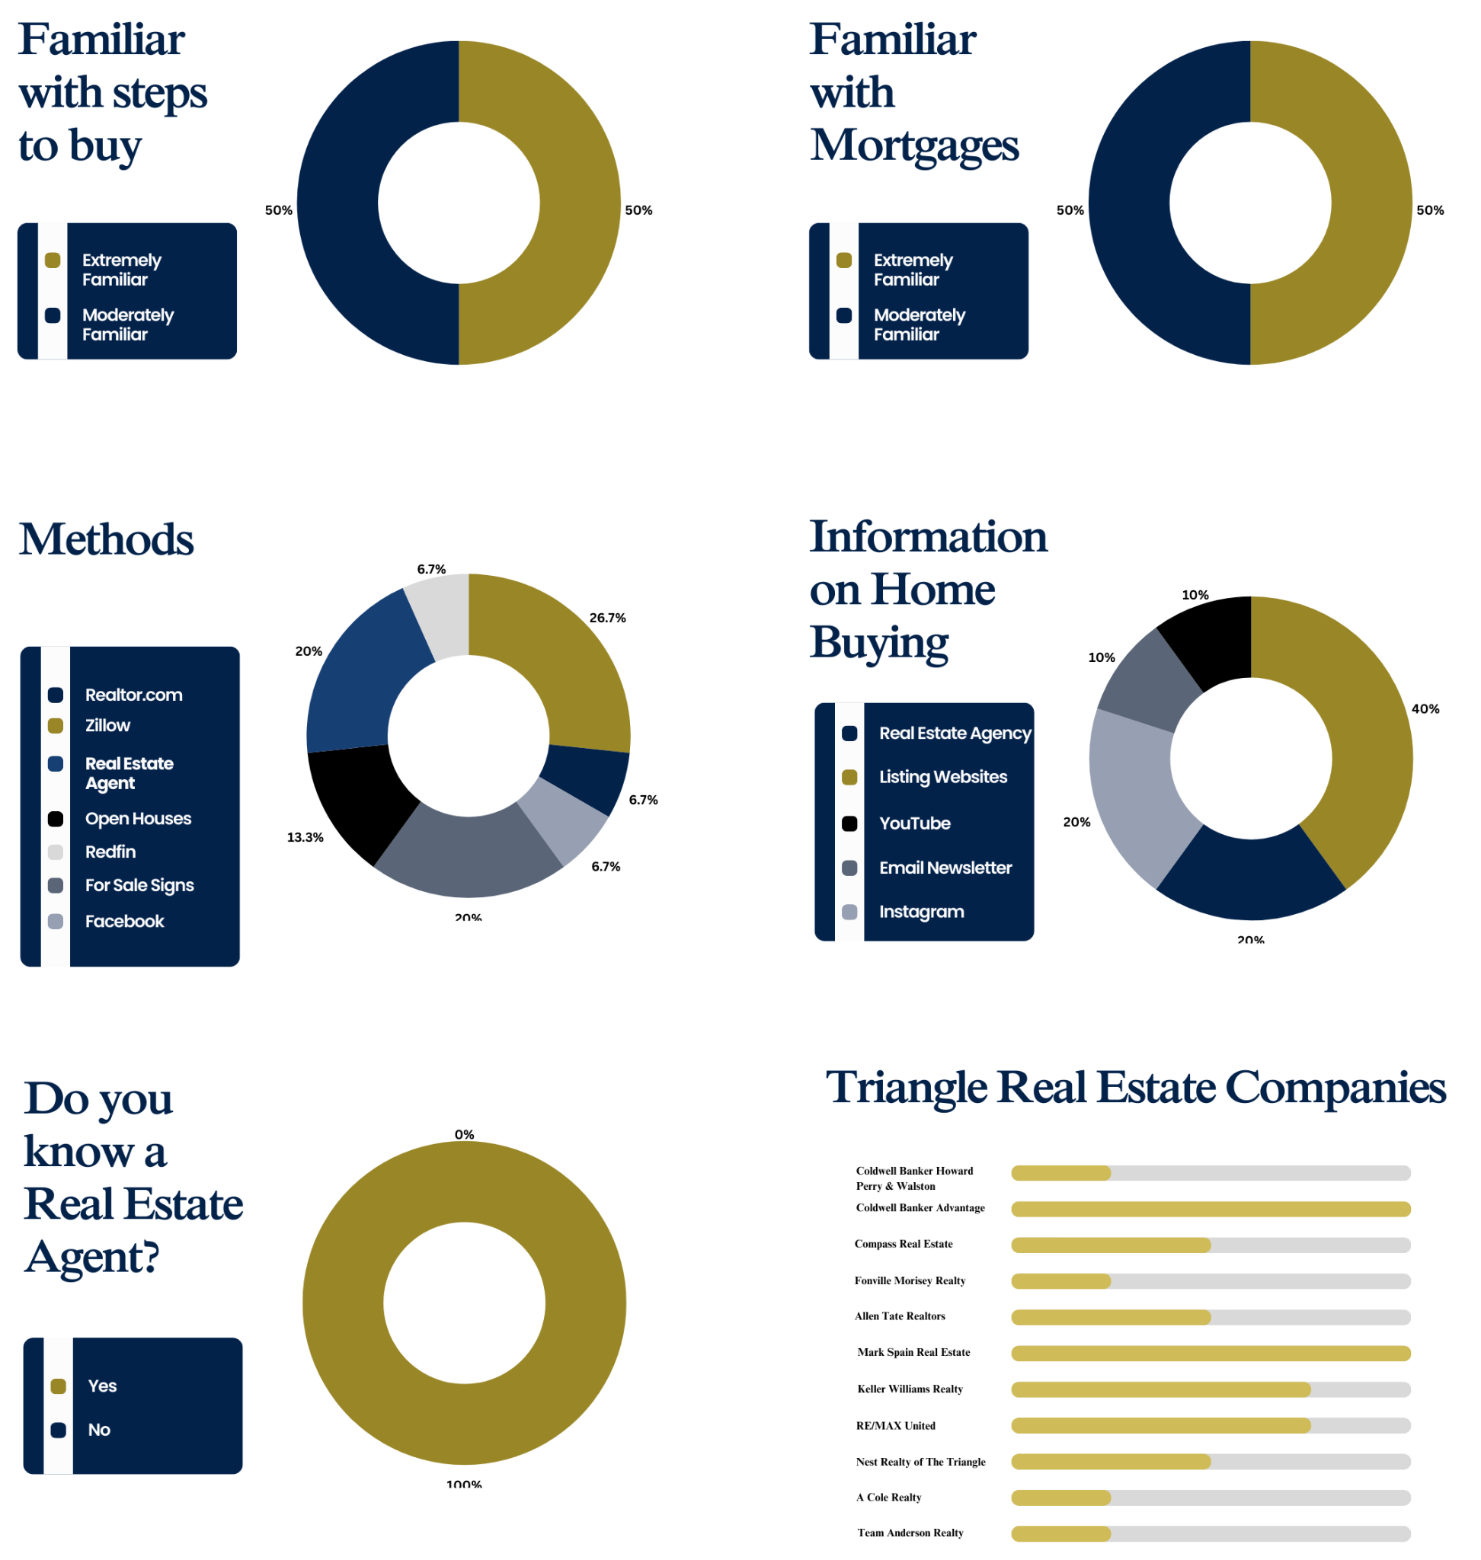
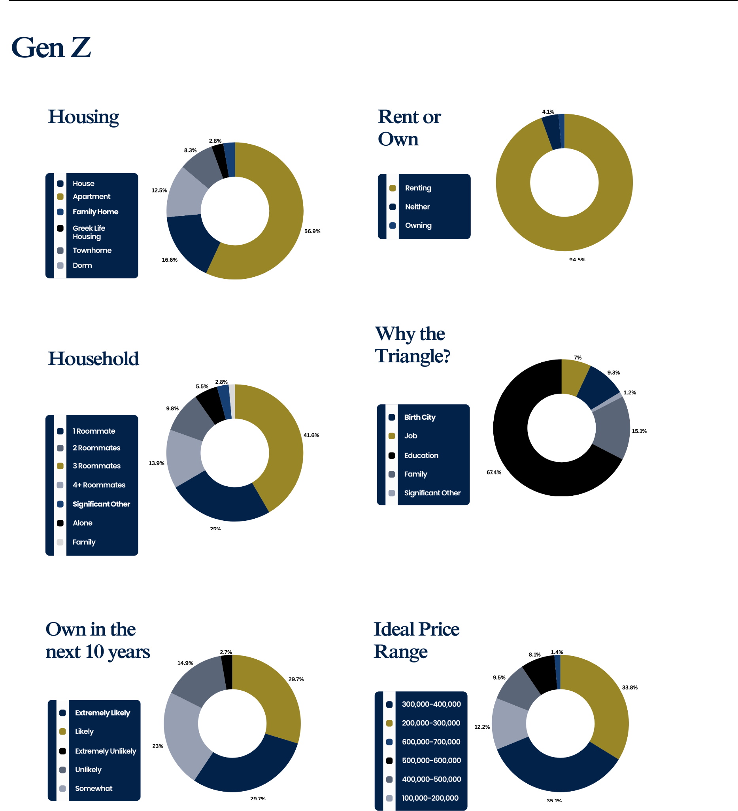
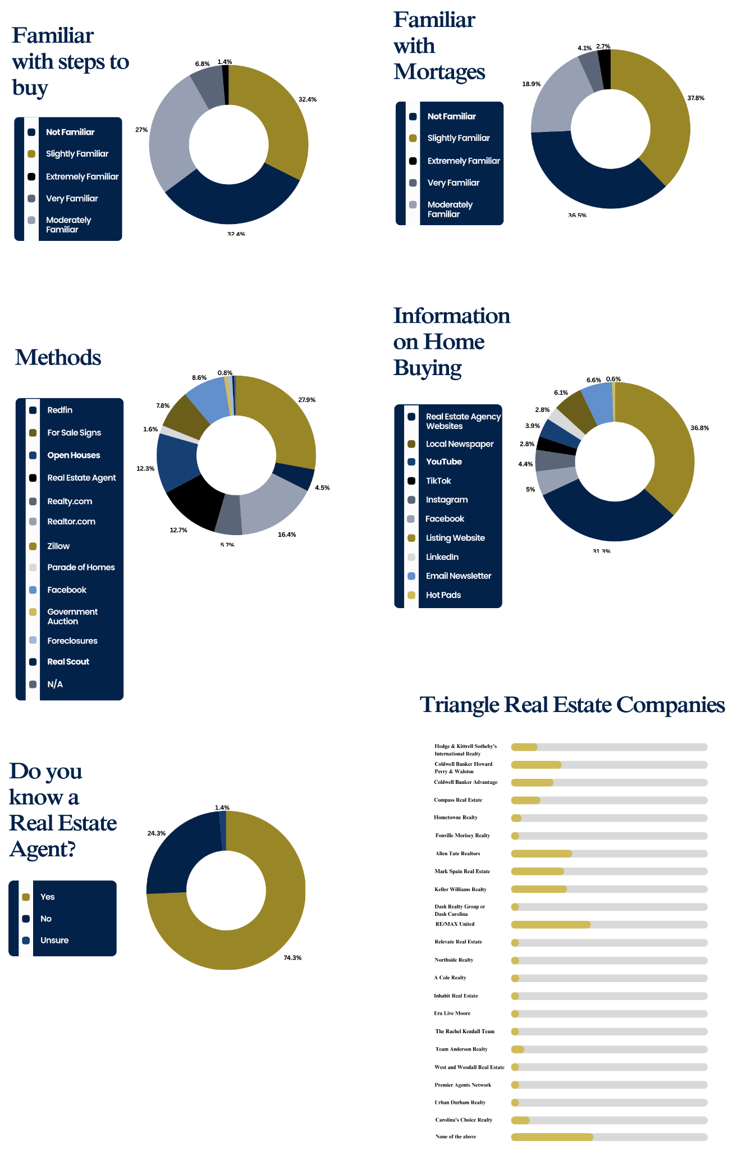

Appendix B: Emily in Raleigh Content Calendar
Emily and her photographer will attend these events and locations every other Monday from January 8th, 2024, through July 22nd, 2024. At each of these, she will take pictures to post on her social media (example in Appendix C). Times are TBD by Emily and specific events. We suggest Emily post at the beginning of the week to allow potential new clients to contact her throughout the week.
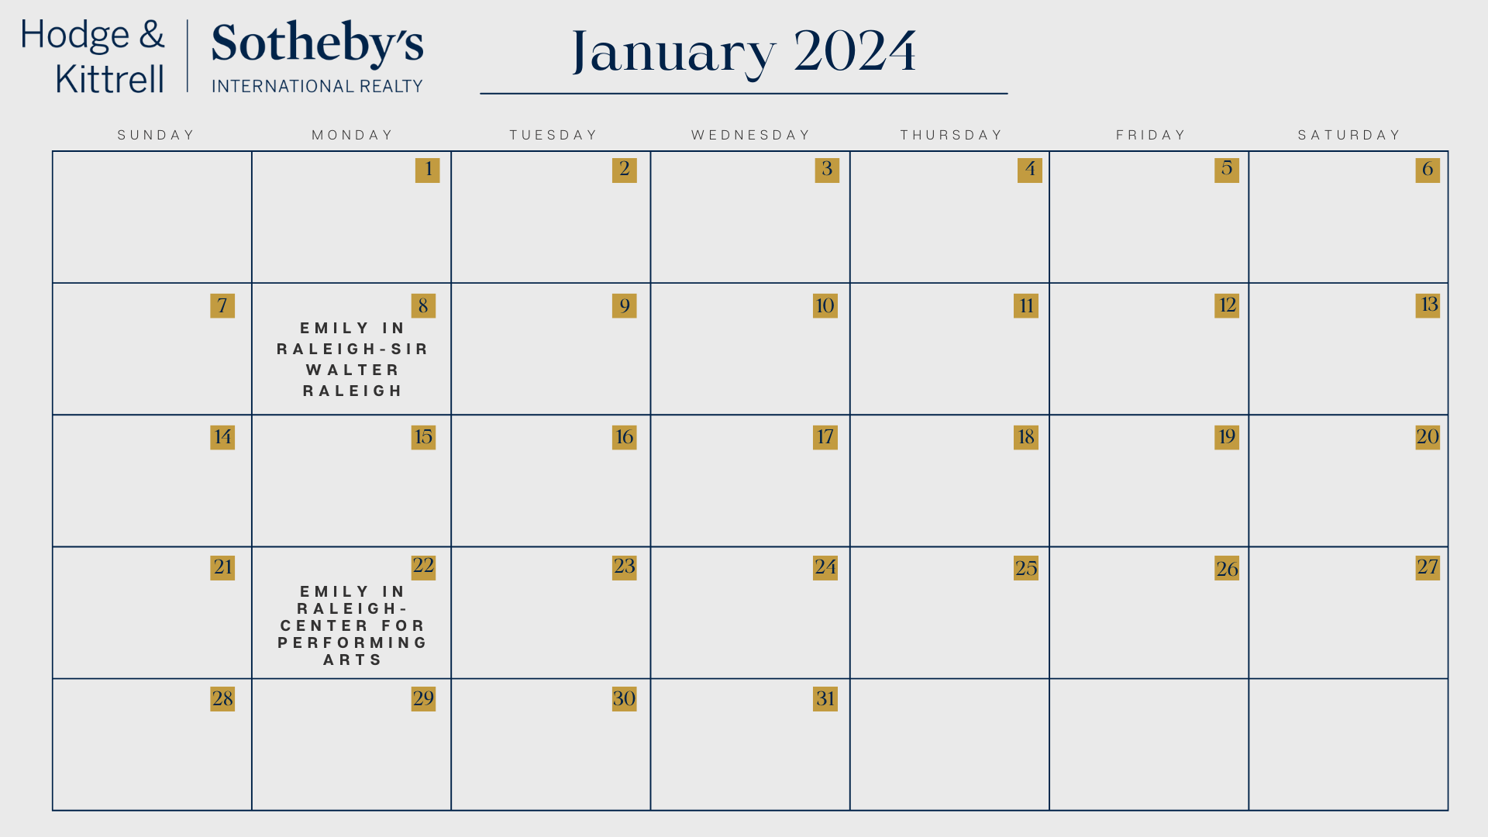
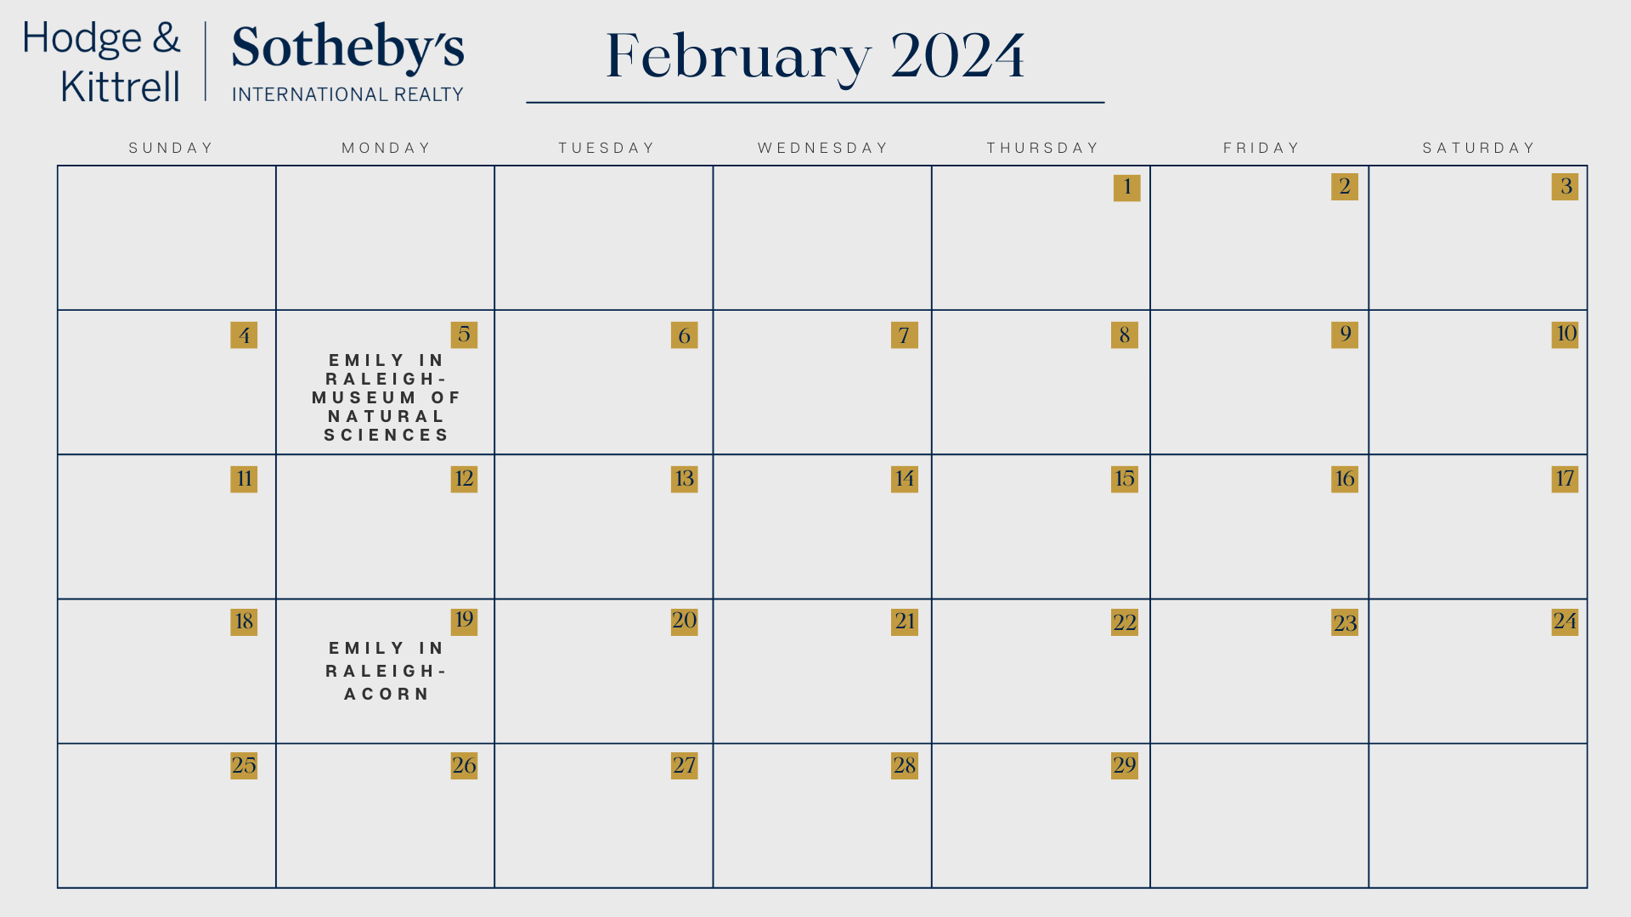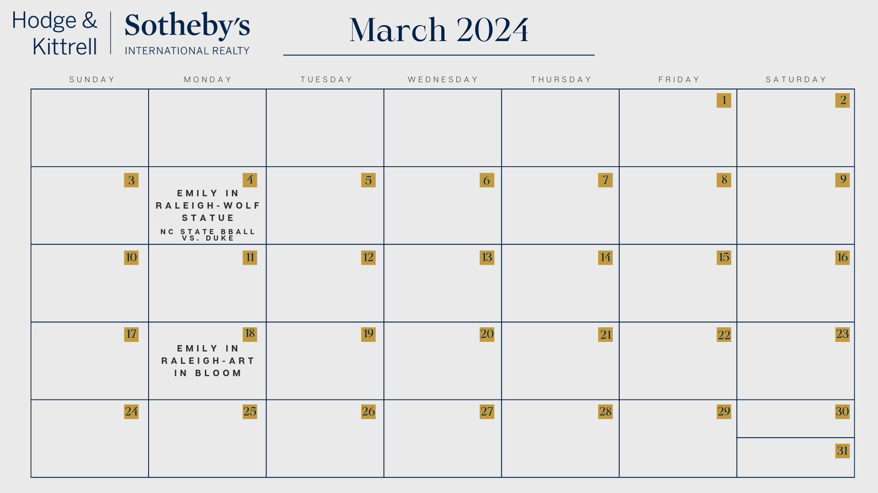
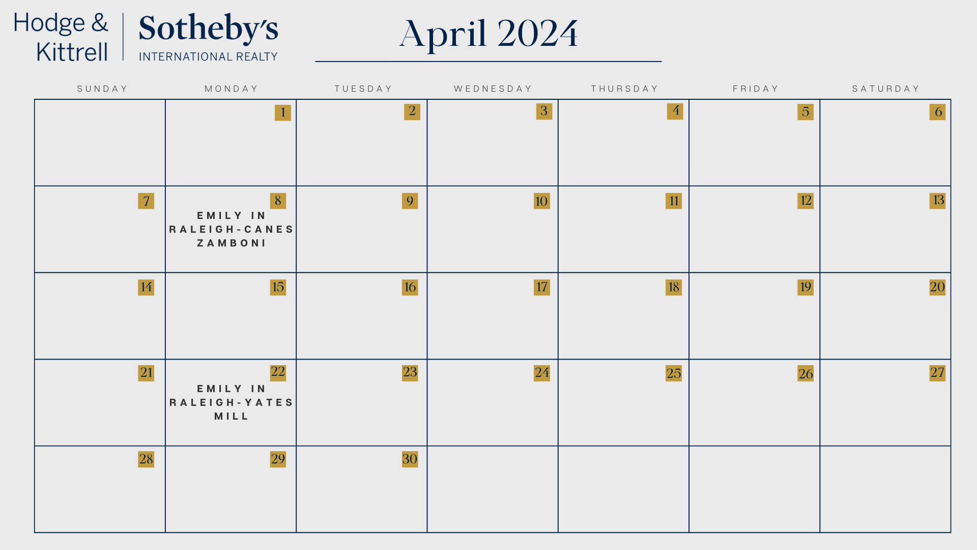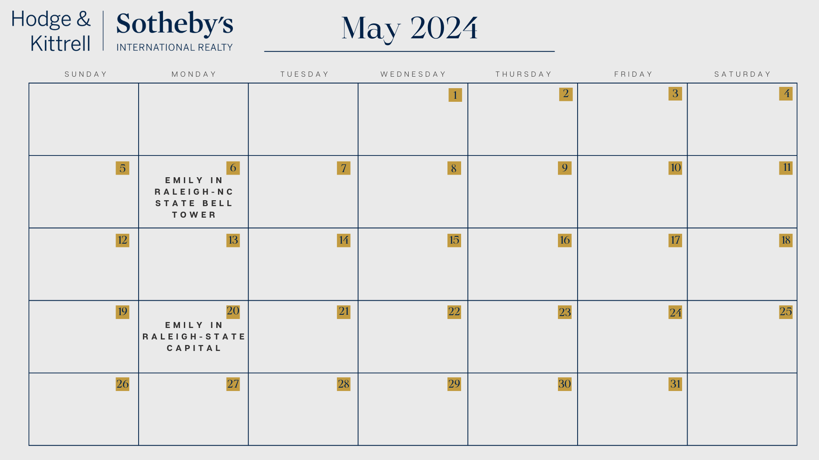
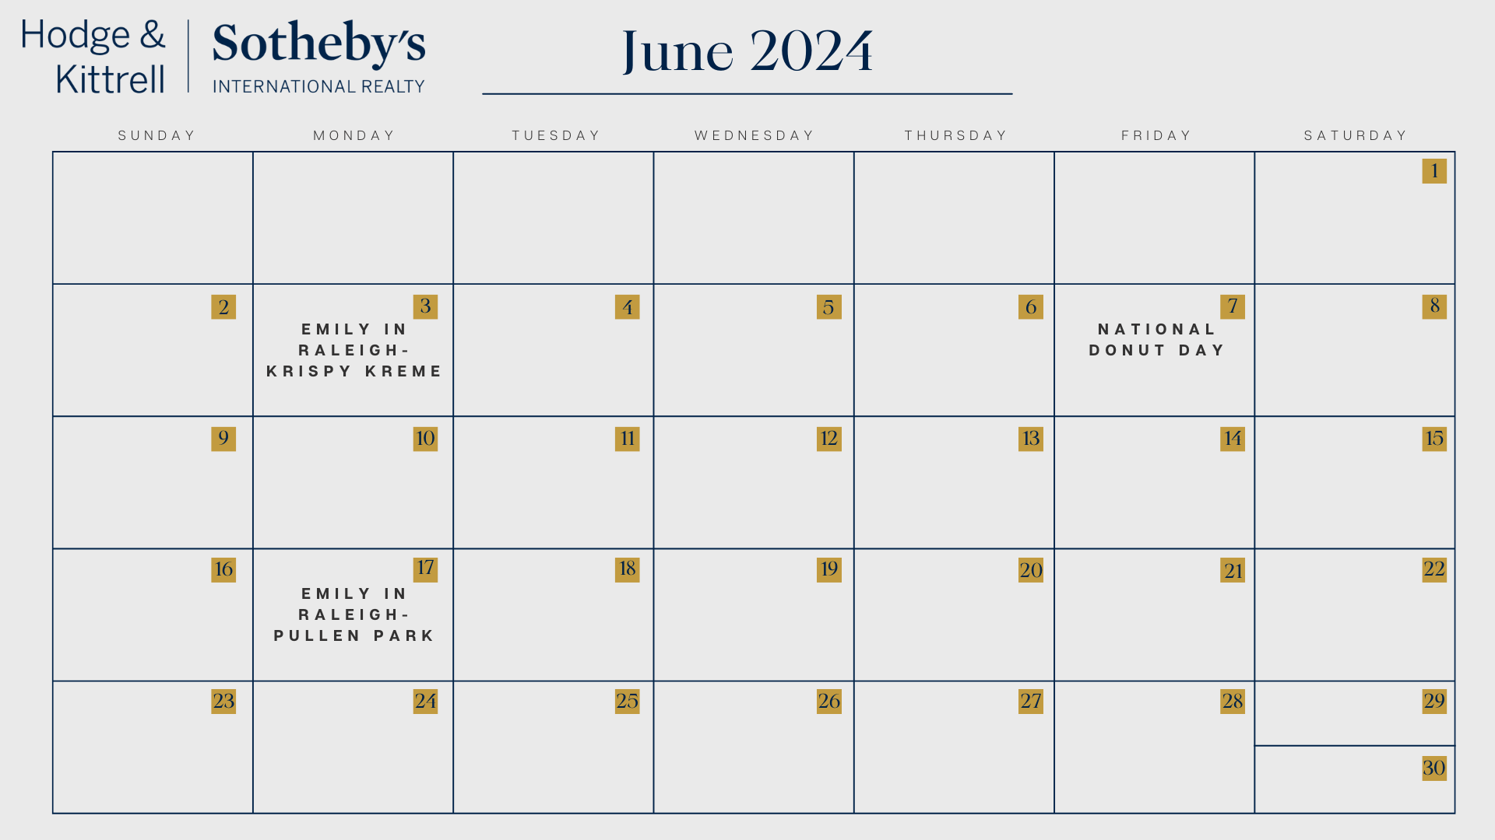
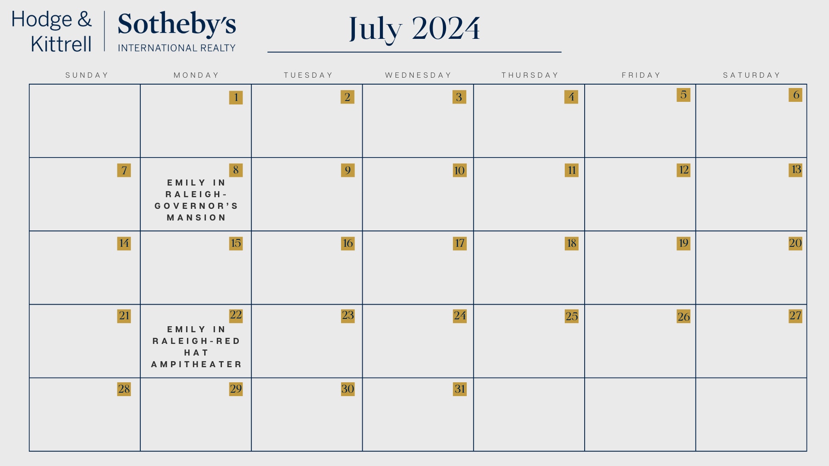

Appendix C: Emily in Raleigh Instagram Posts and Captions
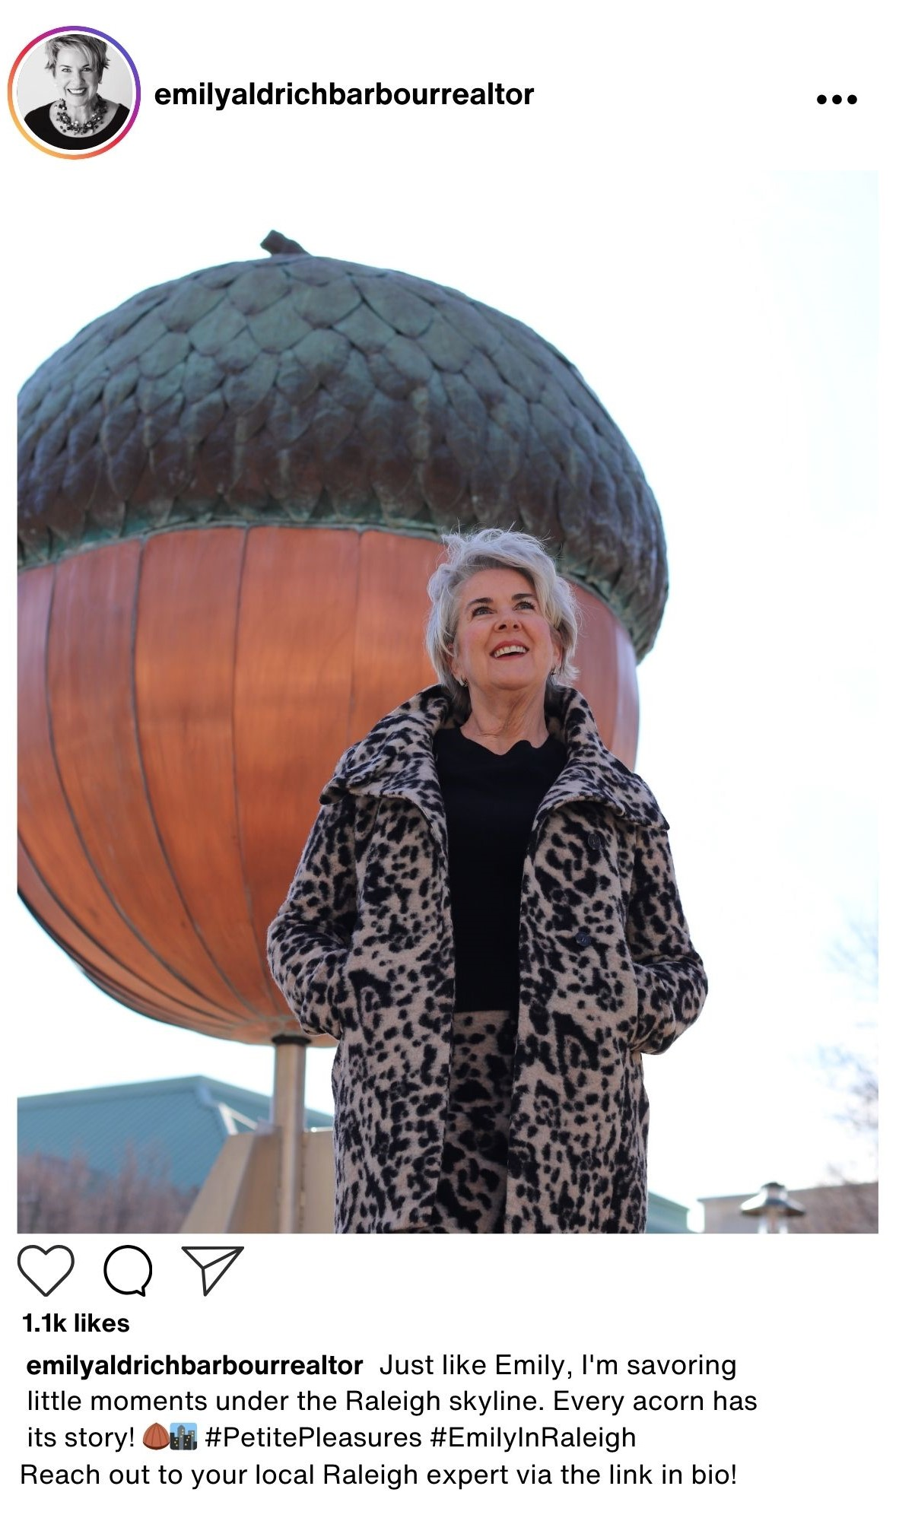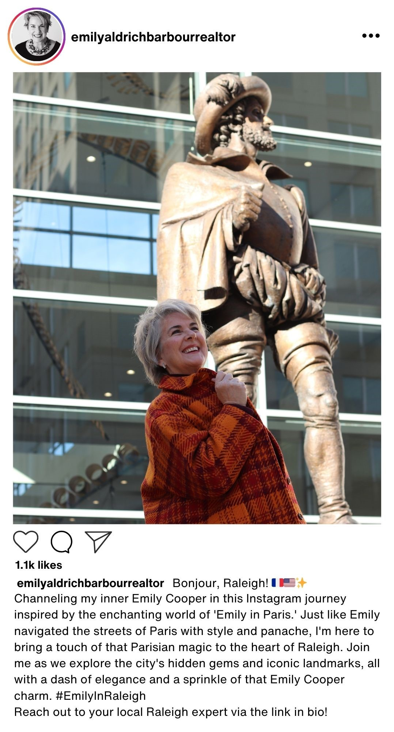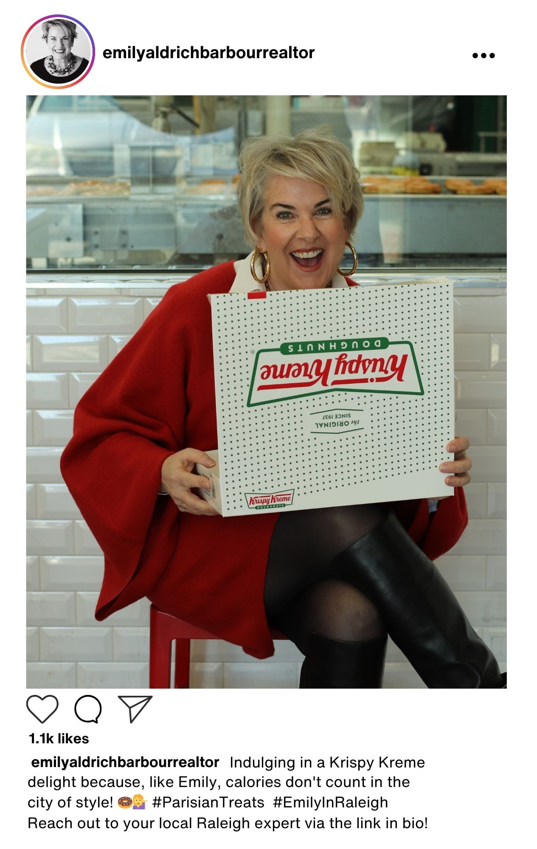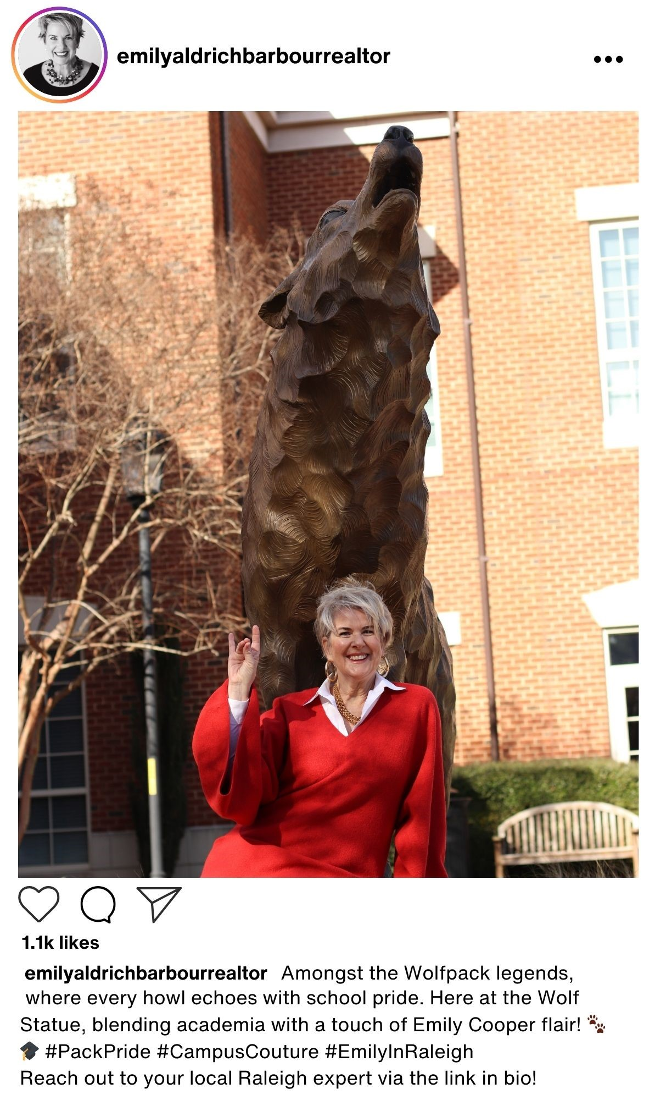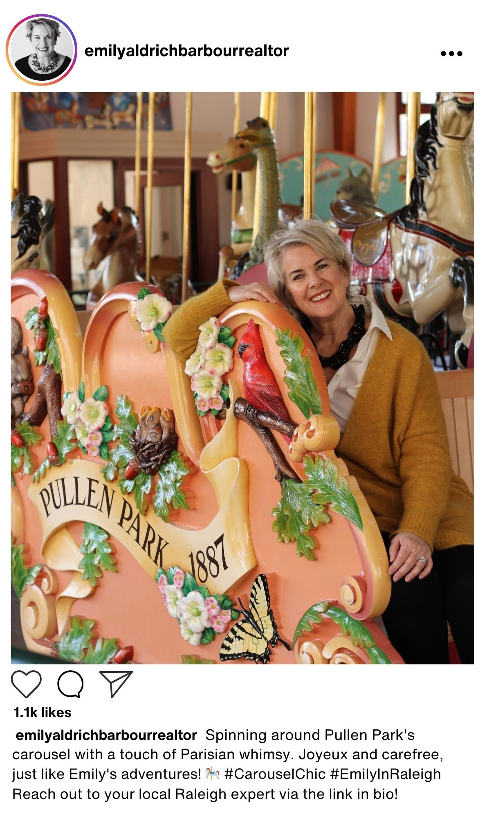

Instagram Mock Posts
Emily relayed her desire to create an “Emily in Raleigh” campaign based on the Netflix TV show “Emily in Paris.” After receiving photos from Emily of her posing in iconic Raleigh locations, we were able to create a mock Instagram post to give Emily an idea of what the posts should look like to attract the most attention from her desired audience. The captions of each post are designed to highlight the Raleigh attraction while also paying homage to the original series for the public to connect with. Each caption also contains #EmilyInRaleigh so that the public can easily find all of Emily’s recent attraction posts and follow along with the campaign. Lastly, we made sure to include a call to action at the end of each caption encouraging the viewer to look at Emily’s profile bio. This encourages the reader to not only click on Emily’s profile and hopefully follow, but also increase website traffic if Emily attaches her website in her bio.

Instagram Captions
- Introduction (Sir Walter Raleigh Statue): “Bonjour, Raleigh! 🇫🇷🇺🇸✨ Channeling my inner Emily Cooper in this Instagram journey inspired by the enchanting world of 'Emily in Paris.' Just like Emily navigated the streets of Paris with style and panache, I'm here to bring a touch of that Parisian magic to the heart of Raleigh. Join me as we explore the city's hidden gems and iconic landmarks, all with a dash of elegance and a sprinkle of that Emily Cooper charm. #EmilyInRaleigh #InspiredByEmilyInParis”
- The Acorn: “Just like Emily, I'm savoring the little moments under the Raleigh skyline. Every acorn has its story! 🌰🏙️ #PetitePleasures”
- The NC State Bell Tower: “Ringing in the Wolfpack spirit at the iconic NC State Bell Tower. Emily Aldrich Barbour-approved elegance. 🔔🐺 #ChicCampus”
- Krispy Kreme: “Indulging in a Krispy Kreme delight because, like Emily, calories don't count in the city of style! 🍩💁‍♀️ #ParisianTreats”
- Pullen Park Carousel: “Spinning around Pullen Park's carousel with a touch of Parisian whimsy. Joyeux and carefree, just like Emily's adventures! 🎠 #CarouselChic”
- Carolina Hurricanes (Zamboni): “Zamboni dreams and hockey scenes – Emily in Paris meets Canes style! 🏒 #IceQueenChic”
- NC Museum of Art (Art in Bloom): “Embracing the artistry of Raleigh at the NC Museum of Art's 'Art in Bloom.' A floral fantasy, à la Emily Aldrich Barbour! 🌸🎨 #ArtfulBlooms”
- State Capital: “Strolling through history at the State Capital, where elegance meets the enduring charm of Emily in Paris. 🏛️ #TimelessStyle”
- Governor’s Mansion: “Living the lavish life at the Governor's Mansion – because every Emily deserves a touch of opulence. 🏰💄 #SophisticatedEscape”
- Yates Mill: “Wandering through the enchanting beauty of Yates Mill, where nature meets Emily's Parisian chic. 🌾 #RusticElegance”
- NC Museum of Natural Sciences: “Exploring the wonders of science at the NC Museum of Natural Sciences, just like Emily, who finds beauty in every discovery. 🔬🌍 #ScientificCharm”
- Symphony/Ballet/Opera/NC Theatre at Durham Performing Arts Center or Martin Marietta Center for Performing Arts: “Dressed in city lights and immersed in culture at the Martin Marietta Center for Performing Arts. Emily in Paris, meet Raleigh's artistic allure! 🎭🌃 #CulturalEscape”
- Red Hat Amphitheater: “Rocking out at the Red Hat Amphitheater – Emily Aldrich Barbour style. Because in Raleigh, every concert is a chic affair! 🎶 #ConcertCouture”
- Wolf Statue: “Amongst the Wolfpack legends, where every howl echoes with school pride. Here at the Wolf Statue, blending academia with a touch of Emily Cooper flair! 🐾🎓 #PackPride #CampusCouture”

Appendix D: Emily’s Online Presence Content Analysis & Tips
To better understand Emily’s current online presence, our team conducted a content analysis of her Instagram and Facebook accounts using a Google Form codesheet. By reviewing Emily’s 31 most recent posts across both platforms, we gathered key information about her professional persona. Most notably, it was clear that Emily’s Instagram is more so focused on showcasing a balance of content between her personal life and her career as a real estate agent. Emily currently uses her Instagram as a photo album of her life, rather than a branding tool to build her reputation, engage with prospective clients, and share her success.
In order to identify the ways Emily can enhance her professional persona online, we pinpointed the key things that are missing from Emily’s current posts. First off is a comprehensive caption that includes a call to action. She can direct people to visit her website or contact her for their real estate needs by including a call to action in her captions. This can be as simple as “Visit the link in my bio to contact me!” but still increase her website traffic and convert social media followers to real clients. Next is making information about her services and client offerings easily accessible. As someone who is aiming to gain new clients online, Emily should make sure to repeat her skill set often in her posts. This helps to push anyone who comes across her content to understand how her expertise is valuable. This is also a branding strategy to reinforce key message themes that Emily wants to emphasize about herself (ex: trustworthy, attentive, quirky, fun).
One of Emily’s biggest successes in her online presence is an overwhelmingly positive sentiment across her social media accounts. She does not have any hate comments or dislikes. As she continues to grow her following, this might change as people who are not her family and friends interact with her content. Hate is inevitable as a social media personality, even if you are using the platform for professional reasons. Emily can anticipate and prepare for this by using Instagram’s comments screening tools to remove comments with certain words from appearing on her page. However, we are positive that this targeted campaign towards Millennials and Gen Z individuals who are interested in homebuying with add to the positive sentiment Emily has curated thus far.
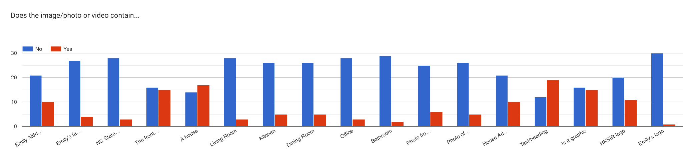

Photo from
an event
Photo of marketing materials
House
Address
Text or
Heading
Emily Aldrich
Barbour
Emily’s
family
NC State symbols
Front of
a house
Is a graphic

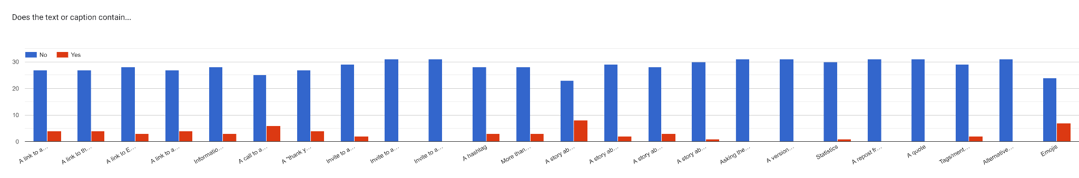
A link to an
external source
A link to the HKSIR website
A link to the Emily’s profile
A link to a
house listing
Information about services
A call to action
A “thank you” to followers
Invite to an open house
Invite to an parade of house
Invite to an event
More than one hashtag
A story about Emily
A story about a homeowner
A story about a homebuyer
A story about a homeseller
Asking the public a question
A version of the mission
Statistics
A repost from the HKSIR IG
A quote
Tags/mentions
of other accounts
Alternative text formatting
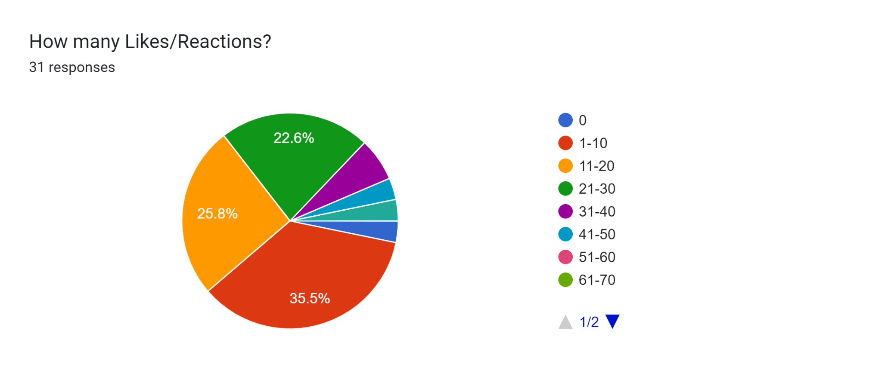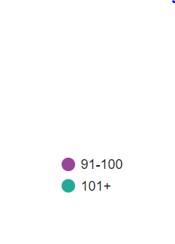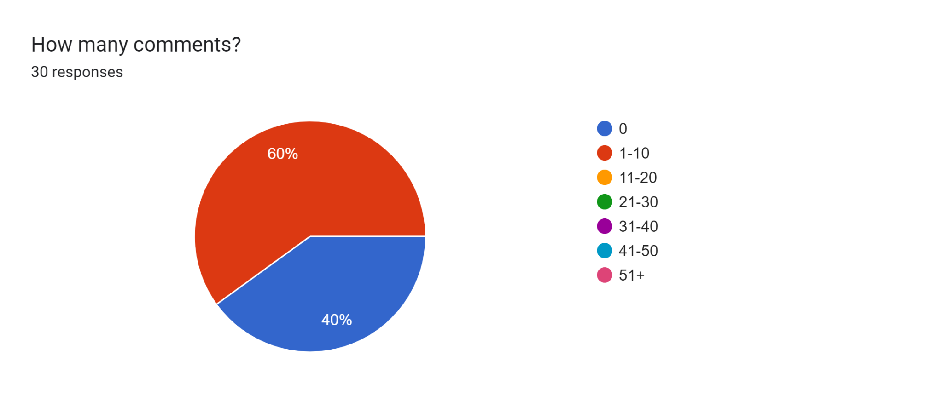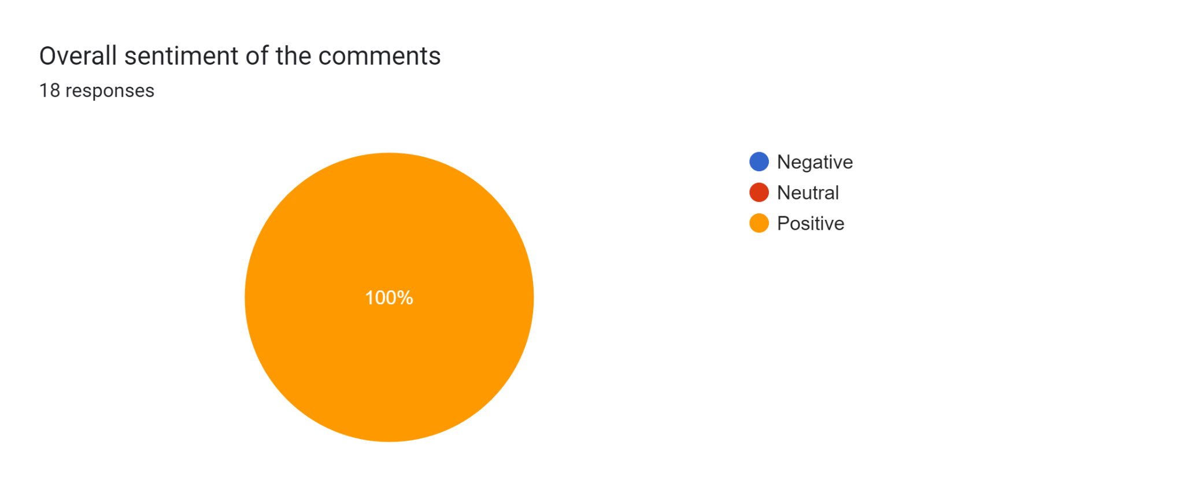
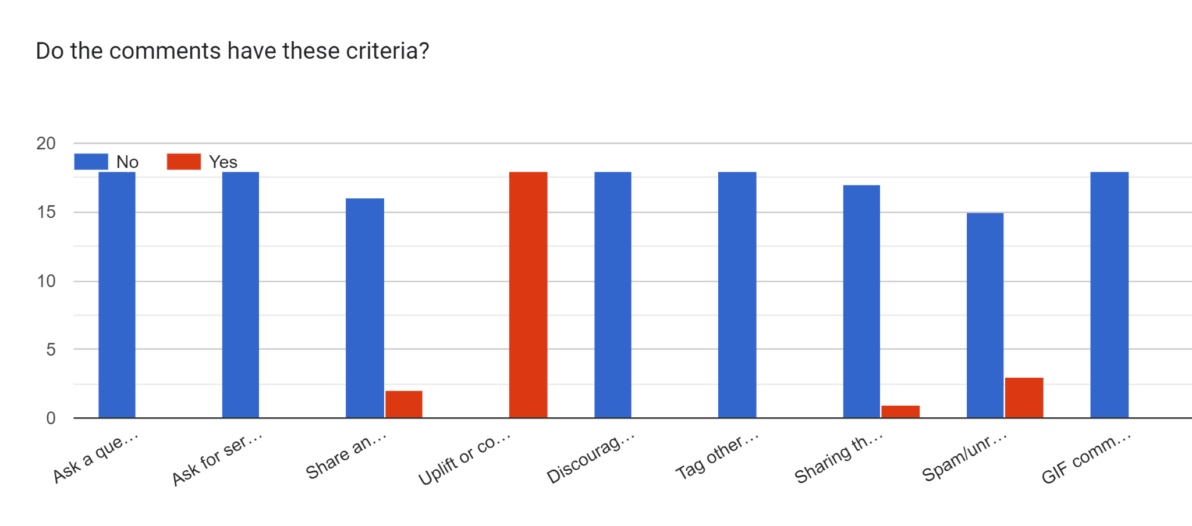
Ask a
question
Ask for
services
Share an
experience
Uplift or
commend
Discourage or criticize
Tag other accounts
Sharing their opinions on Emily
Spam/unrelated to content
GIF comment
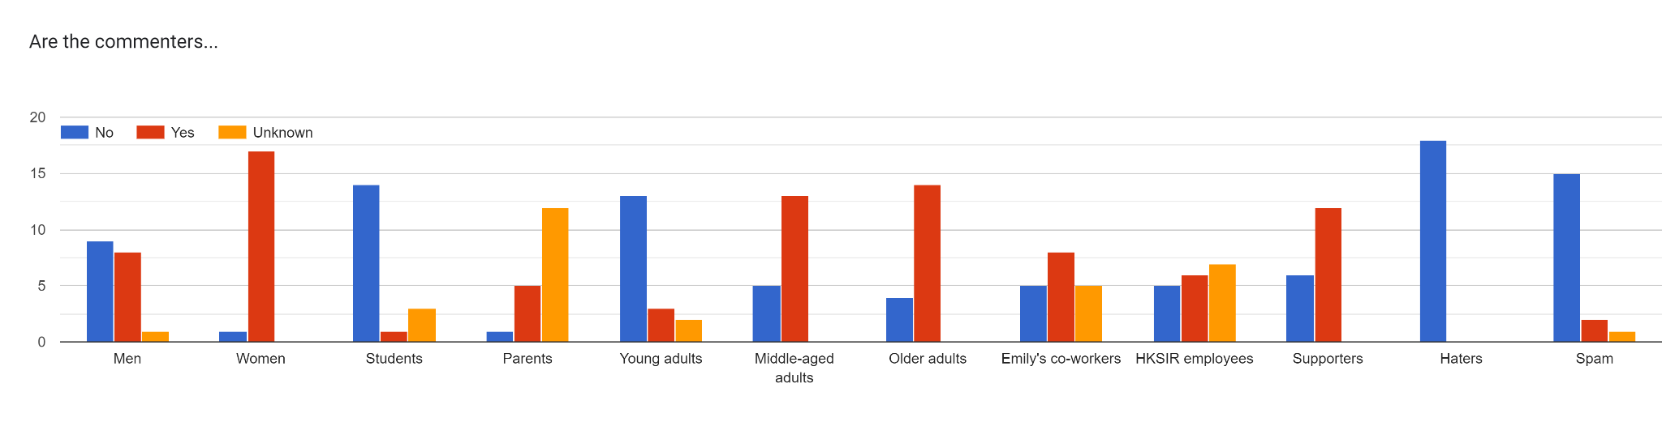

Appendix F: PR Campaign Budget
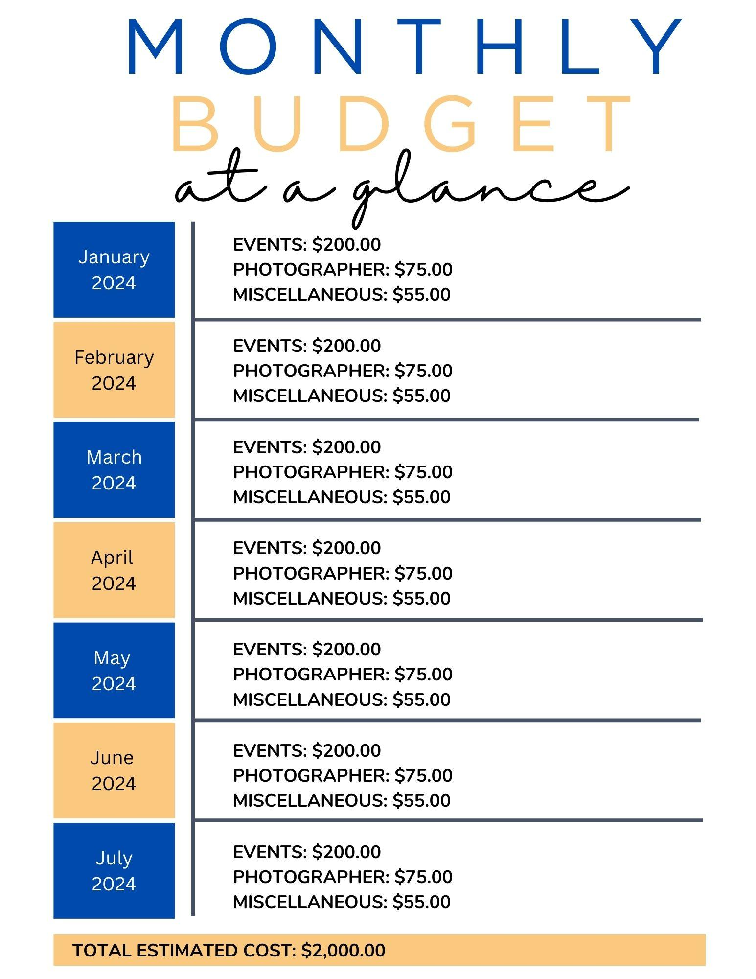
Due to our team’s focus on revamping digital and social media approaches for Emily, most of our recommendations are not monetary but rather cost time. Emily mentioned that she expects to spend roughly $2,000 on her ‘Emily in Raleigh’ campaign alone. We agree with this and estimate that our campaign will be within this price range from the months of January through July 2024. This budget does exclude her current outside costs as an agent for Hodge & Kittrell Sotheby’s real estate. We decided that the predominant factors that will influence this total cost are photography and events with remaining funds geared towards additional expenses.

Appendix G: PR Campaign Plan Presentations
During the semester, we presented our progress for this PR campaign plan at different points of completion. We visually communicated our work to our professor and classmates through powerpoint presentations of the content included in this paper. This is a helpful resource to help digest and understand the key concepts of this plan. Please access them through the hyperlinks below:
- COM 476: HKSIR SWOT & Situational Analysis
- HKSIR Final Presentation

